TOPIC: School | SUBTOPICS: school life; places at school; school activities; recycling | LEVEL: A2
Name: ____________________________ Surname: ____________________________ N^{ber}: ____ Grade/Class: _____

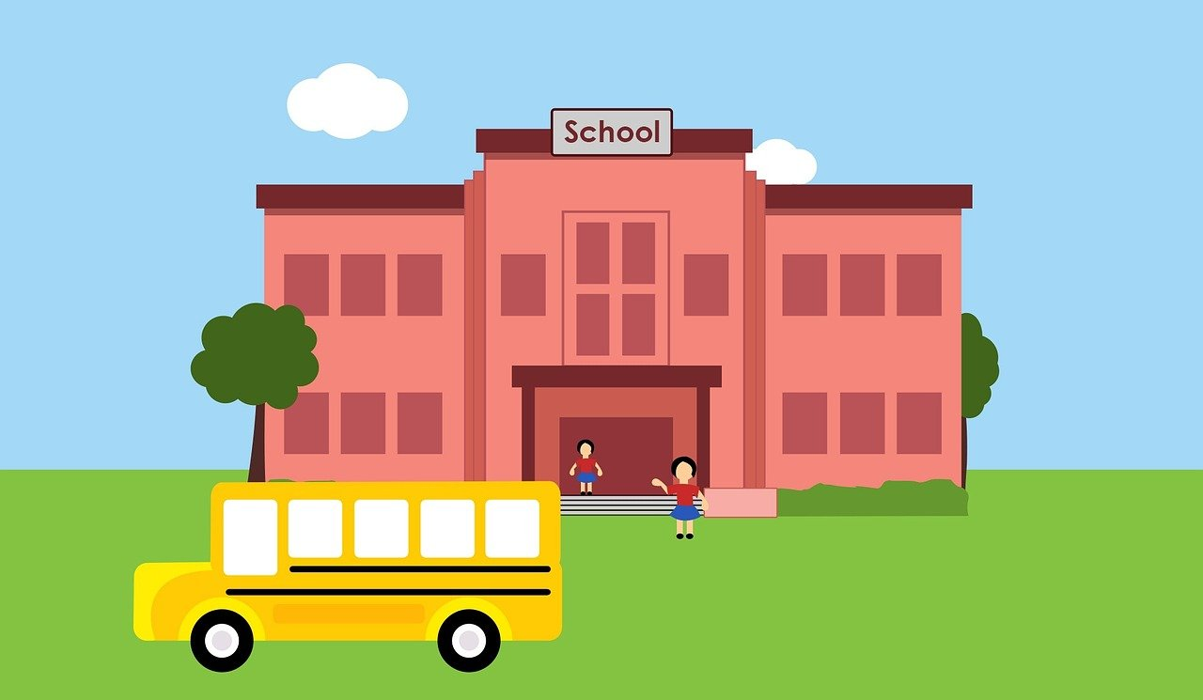
Read the text.
My eco-friendly school

Hello! I’m Jason and I’m in class 4A. My school is called Eastwood Primary School. I’ve got lots of friends and the teachers are nice.
My school is big. There are twelve classrooms and a big library with lots of books and fifteen computers. The library is my favourite part of school. I like reading and playing computer games. There is a big playground. I love playing football but I don’t like playing hide and seek. In the playground there are three recycling bins: the yellow bin, the green bin and the blue bin.
I love my school, it is an eco-friendly school. We all care about the environment. The rules are: 1) Reduce, reuse and recycle; 2) Don’t litter; 3) Don’t waste water.

1. Write Yes or No.

a) Jason is a student. ______
b) He doesn’t like the teachers. ______
c) His school is small. ______
d) There are 15 computers in the library. ______
e) Jason doesn’t like reading. ______
f) Teachers and students use recycle bins. ______

2. Read the text again and answer the questions
- It ___ ___________ ___________ __________.
- There ______ __________ ________________.
- It ______ ______________ ________________.
- They ______ _____ _____ __________________.
a) What is the name of Jason’s school?
b) How many classrooms are there?
c) What is Jason’s favourite playground activity?
c) Where are the recycling bins?
3. Match.
a) … glass.
b) … plastic and metal.
c) … paper and cardboard.

- The yellow bin is for …
- The blue bin is for …
- The green bin is for …

4. Which bin? Write.
can glass bottle shoebox carton of milk glass jar newspaper

YELLOW BIN BLUE BIN GREEN BIN

________________
________________
________________
________________
________________
________________

5. Match.
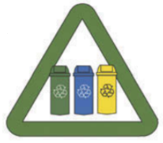
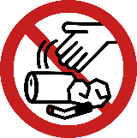

a) | b) | c)

1)  Reduce, reuse, recycle! | 2)  Don’t waste water! | 3)  Don’t litter

