TOPIC: School | SUBTOPICS: school life; places at school | LEVEL: A2
Name: ____________________________ Surname: ____________________________ N^{ber}: ____ Grade/Class: _____

1. Read the text and fill in the gaps.
gym
library
school
playground
classrooms
computer room
canteen

Dear grandma,
How are you? I’m great and everything’s so nice here in Oxford but I really miss you.
Today is my first day of _______________. It’s really awesome. I’m in class 4B and my new teacher is very cool. My friends Jane and Peter are in my class too. Jane is 9 years old and so is Peter.
My school is called Jefferson Primary School and there is a big ___________________ where we can play football and hide and seek in the interval.
There is also a _________________ and food is delicious. There are ten ___________________ and a big ________________ to do gymnastics.
There is a big __________________ with twelve computers and there’s a super new _________________ too, with lots and lots of books. It’s my favourite part of school. I really love my new school!
Write soon. Love to grandpa,
Daisy

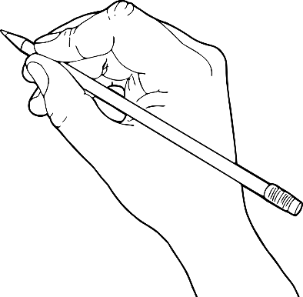

2. Write Yes or No.

a) Daisy is writing a letter to her grandfather. ____
b) Jane and Peter are nine. ____
c) The gym is small. ____
d) There isn’t a canteen at school. ____
e) Daisy loves the library. ____
f) Daisy doesn’t like her school. ____

3. Answer the questions.
- She _____________________________________________.
- ________, ________ __________.
- It _______________________________________________.
- There ___________________________________________.
- They ____________________________________________.

a) What class is Daisy in?
b) Has she got friends in her class?
c) What is the name of the school?
d) How many classrooms are there?
e) Where are the computers?

