Name: ____________________________ Surname: ____________________________ N^{ber}: ____ Grade/Class: _____
Assessment: _____________________________ | Date: ___________________________________________________
 | Teacher’s signature:  ___________________________ | Parent’s signature:  ___________________________

- Look at the picture.

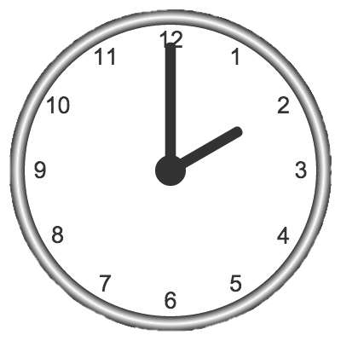

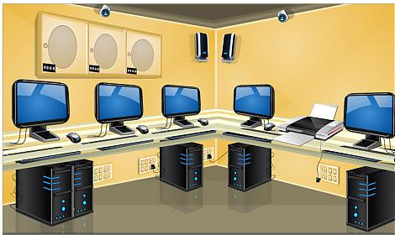
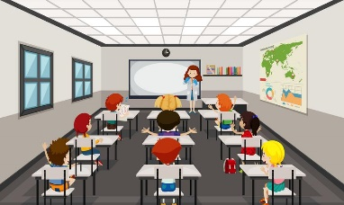
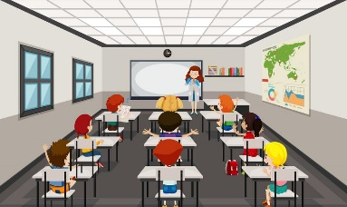

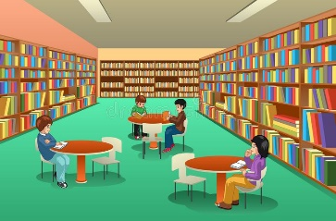
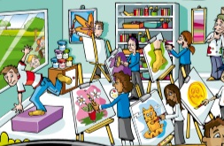
Kate

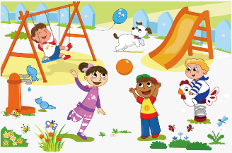

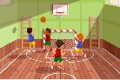
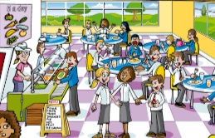
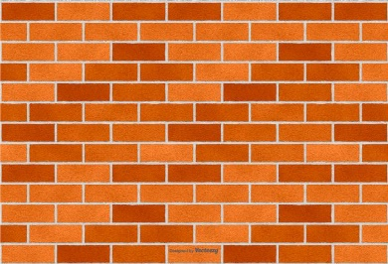

Tom

- Write Yes or No.

- It’s two o’clock in the morning. _______
- There are students in the playground. _______
- There is a slide in the playground. ______
- There isn´t a computer room. _______
- The students in the gym are playing basketball. _______
- There are three students in the music room. _______
- Tom is drawing. _______
- Kate is dancing. _______
- There are three bins for recycling. ______
- The recycling bins are in the canteen. ______

ANSWER KEY

EXERCISE 2
- no
- yes
- yes
- no
- yes
- yes
- no
- no
- yes
- no

