Name: ____________________________ Surname: ____________________________ N^{ber}: ____ Grade/Class: _____
Assessment: _____________________________ | Date: ___________________________________________________
 | Teacher’s signature:  ___________________________ | Parent’s signature:  ___________________________

Read and complete the text.

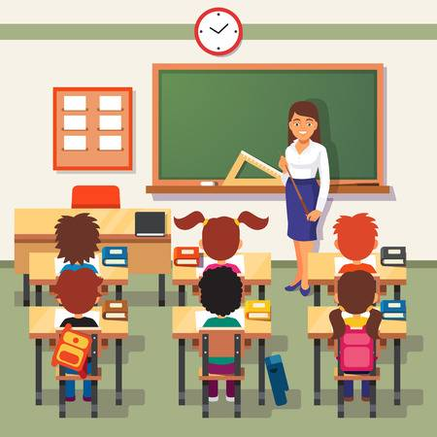
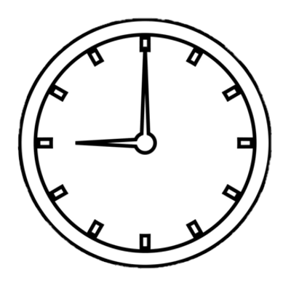

reading * classroom * is * teacher * 13th * years * singing * nine

Hi, my name 1)________________ Jack and I’m nine 2)________________ old. This is my 3)________________. There are six students in my class. And this is my English 4)________________ , her name’s Karen Bennet. Today it’s my birthday. It’s on the 5)________________ of September. Now it’s 6)________________ o’ clock. Time to start the lessons! My favourite classroom activity is 7)________________ stories. I don’t like 8)________________ songs.

ANSWER KEY

- is
- years
- classroom
- teacher
- 13th
- nine
- reading
- singing

