Name: ____________________________ Surname: ____________________________ N^{ber}: ____ Grade/Class: _____
Assessment: _____________________________ | Date: ___________________________________________________
 | Teacher’s signature:  ___________________________ | Parent’s signature:  ___________________________

STUDENT A

- Ask your partner: “What is… doing?” / “What are… doing?”

Jonathan
Sue and Jim

Bill and Anne
Megan

- Look. Answer your partner’s questions.

 | 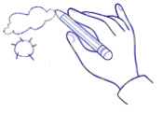 | 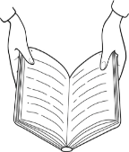
Mary
Stephan
Kim and Ted
The girls

Name: ____________________________ Surname: ____________________________ N^{ber}: ____ Grade/Class: _____
Assessment: _____________________________ | Date: ___________________________________________________
 | Teacher’s signature:  ___________________________ | Parent’s signature:  ___________________________
STUDENT B

- Look. Answer your partner’s questions.

 | 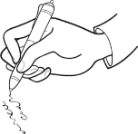 | 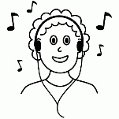 | 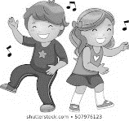 | 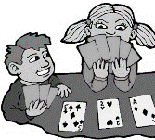
Jonathan
Megan
Sue and Jim
Bill and Anne

- Ask your partner: “What is… doing?” / “What are… doing?”

Mary
Kim and Ted

The girls
Stephan

ANSWER KEY

St A: What is Jonathan doing?
St B: He is listening to music.
St A: What is Megan doing?
St B: She is writing.
St A: What are Sue and Jim doing?
St B: They are dancing.
St A: What are Bill and Anne doing?
St B: They are playing cards.

St A: What is Mary doing?
St B: She is reading.
St A: What is Stephan doing?
St B: He is playing on the computer.
St A: What are Kim and Ted doing?
St B: They are singing.
St A: What are the girls doing?
St B: They are drawing.

