Name: ____________________________ Surname: ____________________________ N^{ber}: ____ Grade/Class: _____
Assessment: _____________________________ | Date: ___________________________________________________
 | Teacher’s signature:  ___________________________ | Parent’s signature:  ___________________________

Find the 10 differences.

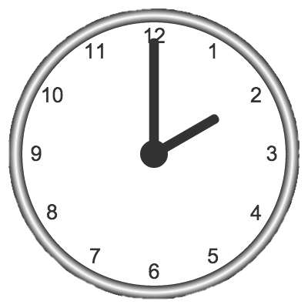
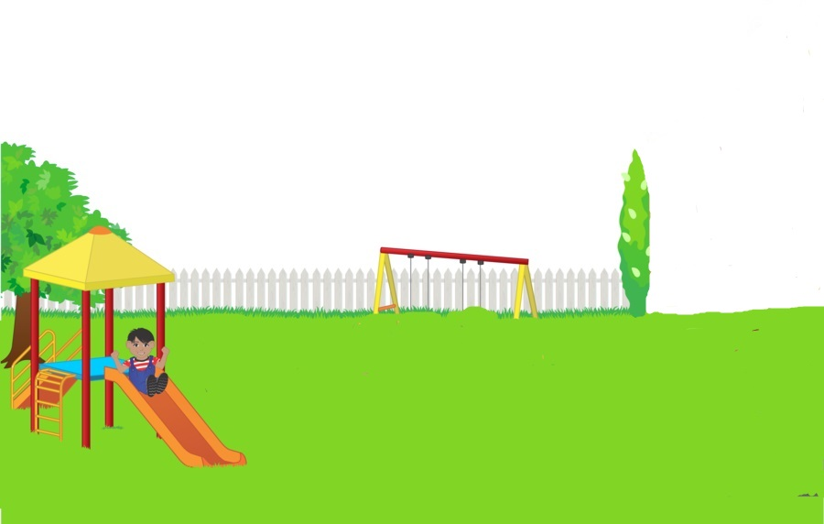

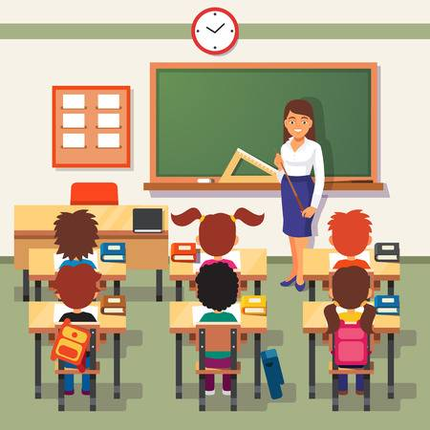
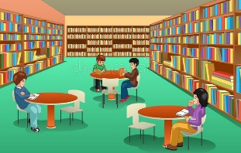

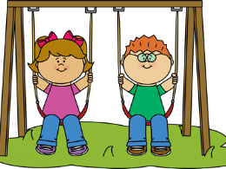

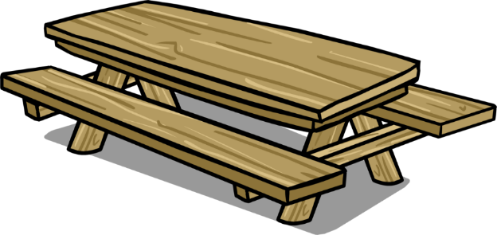

Name: ____________________________ Surname: ____________________________ N^{ber}: ____ Grade/Class: _____
Assessment: _____________________________ | Date: ___________________________________________________
 | Teacher’s signature:  ___________________________ | Parent’s signature:  ___________________________

Find the 10 differences.

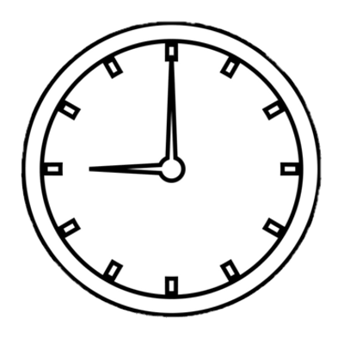

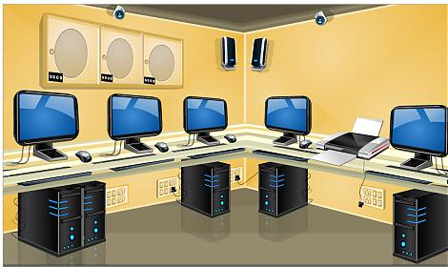

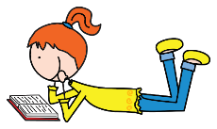
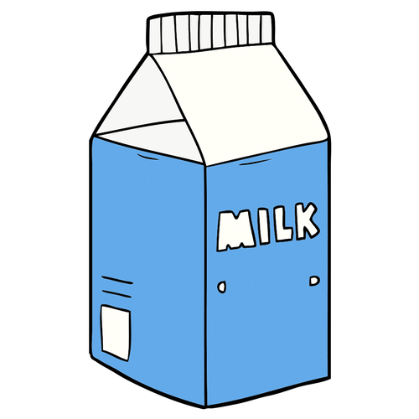

KEY ANSWER

 | PICTURE 1 | PICTURE 2
1 | Two recycling bins | Three recycling bins
2 | A can on the floor, next to the recycling bin | A plastic bottle on the floor, next to the recycling bin
3 | A glass bottle on the table | A carton of milk on the table
4 | A boy playing football | A girl reading a book
5 | Two children are playing on a swing | There is no swing
6 | Two o´clock in the afternoon | Nine o’ clock in the morning
7 | No students in the gym | Two students in the gym
8 | Classroom | Library
9 | Library | Classroom
10 | Music room | Computer room

