Name: ____________________________ Surname: ____________________________ N^{ber}: ____ Grade/Class: _____
Assessment: _____________________________ | Date: ___________________________________________________
 | Teacher’s signature:  ___________________________ | Parent’s signature:  ___________________________

STUDENT A

- Ask your partner: “Where is/are …?”

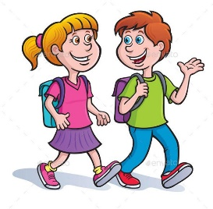

The teacher Emily Sue and Dan

- Look. Answer your partner’s questions.

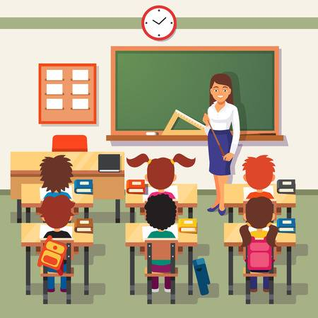

The teacher
Eric
Laura and Jim

Name: ____________________________ Surname: ____________________________ N^{ber}: ____ Grade/Class: _____
Assessment: _____________________________ | Date: ___________________________________________________
 | Teacher’s signature:  ___________________________ | Parent’s signature:  ___________________________
STUDENT B

- Look. Answer your partner’s questions.

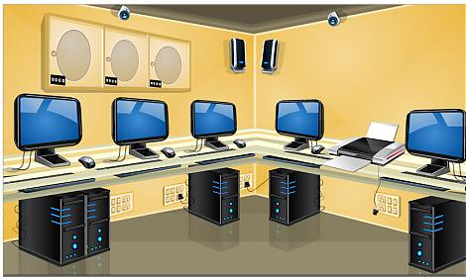

The teacher

Emily

Sue and Dan

- Ask your partner: “Where is/are …?”

The teacher Eric Laura and Jim

ANSWER KEY

St A: Where is the teacher?
St B: He is in the canteen.
St A: Where is Emily?
St B: She is in the computer room.
St A: Where are Sue and Dan?
St B: They are in the playground.

St B: Where is the teacher?
St A: She is in the classroom.
St B: Where is Eric?
St A: He is in the library.
St B: Where are Laura and Jim?
St A: They are in the gym.

