Name: ____________________________ Surname: ____________________________ N^{ber}: ____ Grade/Class: _____
Assessment: _____________________________ | Date: ___________________________________________________
 | Teacher’s signature:  ___________________________ | Parent’s signature:  ___________________________

Look at the picture.
Answer the questions.

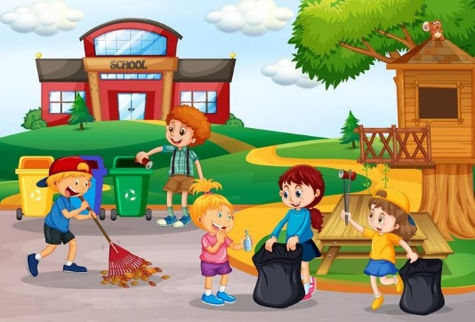

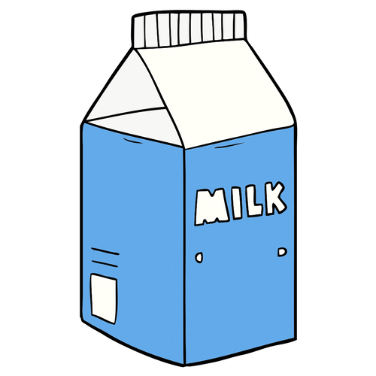
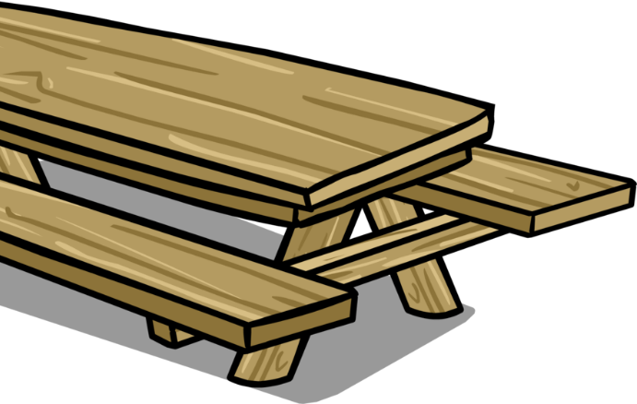
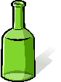
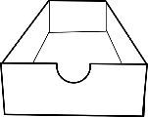
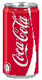
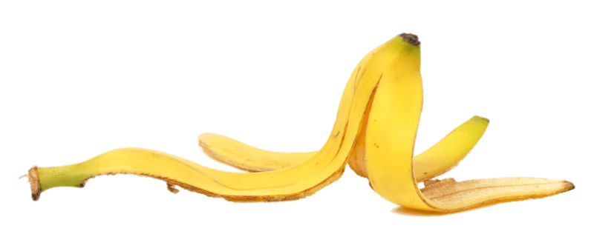

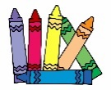
TEACHER’S QUESTIONS:

- Where are the students?
- What are they doing?
- How many recycling bins are there? What colour are they?
- What is the yellow bin for? the blue bin? the green bin?
- What’s this? In which bin do you put it?
(The teacher points to the litter: glass bottle, plastic bottle, carton of milk, can, glass jar, shoebox, newspaper, banana peel)

ANSWER KEY

- They are in the playground.
- They are cleaning up the playground. / They are picking up litter.
- There are three recycling bins: yellow, blue and green.
- The yellow bin is for plastic and metal; the blue bin is for paper and cardboard; the green bin is for glass.
- The glass bottle goes to the green bin;
The plastic bottle goes to the yellow bin;
The carton of milk goes to the yellow bin;
The glass jar goes to the green bin;
The shoebox goes to the blue bin;
The newspaper goes to the blue bin;
The banana peel goes to the black plastic bag.

