Name: ____________________________ Surname: ____________________________ N^{ber}: ____ Grade/Class: _____
Assessment: _____________________________ | Date: ___________________________________________________
 | Teacher’s signature:  ___________________________ | Parent’s signature:  ___________________________

Look at the picture.
Answer the questions.

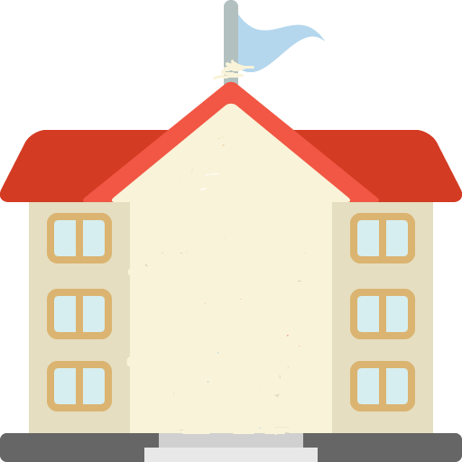
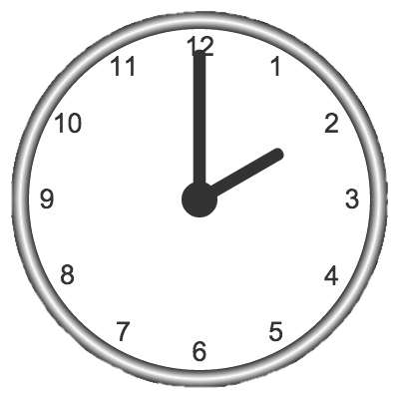
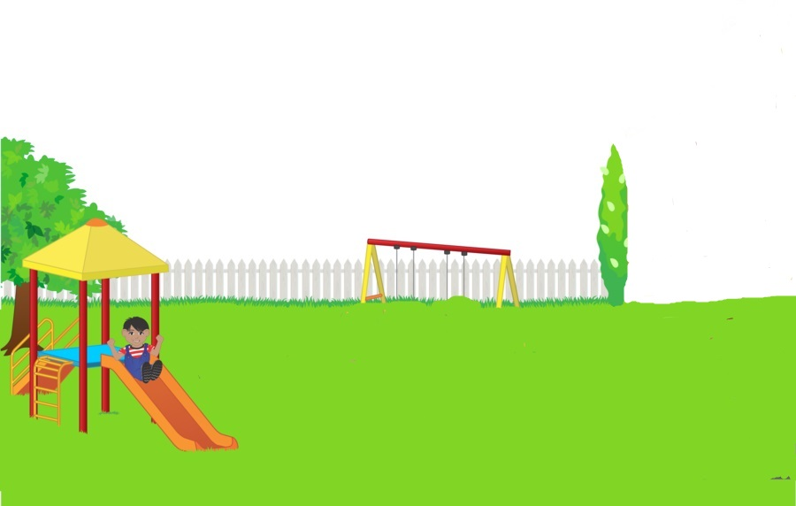
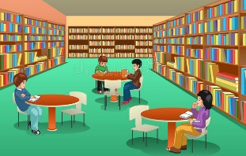
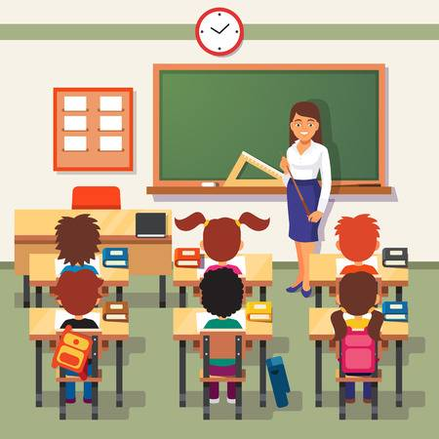
Jenny

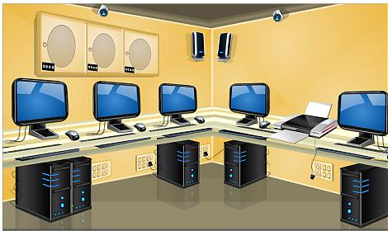

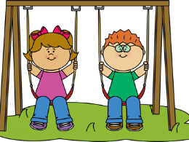
Sam
Jack
Sarah
Paul
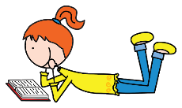
Tom
Kate

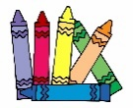
TEACHER’S QUESTIONS:

- Where is Sam? What is he doing?
- What about Tom and Kate, what are they doing?
- How many students are there in the playground?
- Where is Jenny? In your opinion what is she doing?
- Can you identify the different parts of the school?
- Are there recycling bins? Point to them.
- How many recycling bins are there? What colour are they?
- In which bin do you put the glass? Plastic and metal? Paper and cardboard?
- What time is it?

ANSWER KEY

- Sam is in the playground, he is playing football.
- Tom and Kate are reading.
- There are thirteen students.
- Jenny is in the classroom. She is having studying maths.
- Parts of the school: classroom, library, music room, gym, computer room, canteen, playground.
- Yes, there are recycling bins.
- There are three recycling bins.
- They are yellow, blue and green.
- I put the glass in the green bin, plastic and metal in the yellow bin, paper and cardboard in the blue bin.
- It’s two o´clock in the afternoon.

