Name: ____________________________ Surname: ____________________________ N^{ber}: ____ Grade/Class: _____
Assessment: _____________________________ | Date: ___________________________________________________
 | Teacher’s signature:  ___________________________ | Parent’s signature:  ___________________________

Choose the best answer. Put a tick ( ).
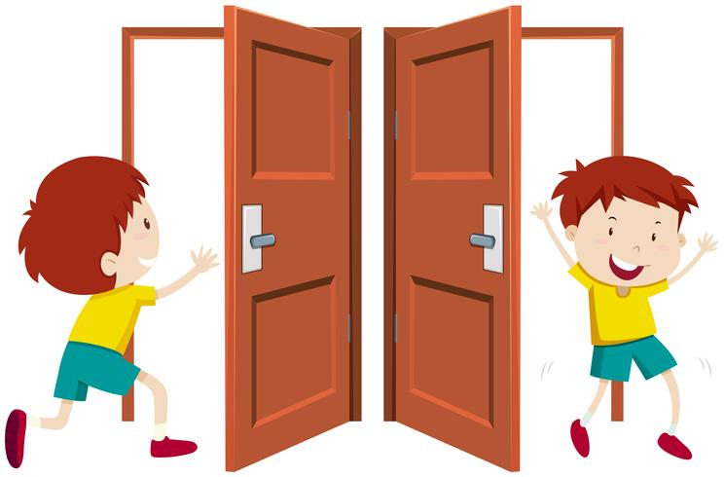
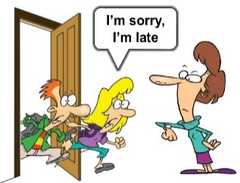

Can I stand up?
May I go out?
Can I sit down?
Can you open the book?
Can I put this in the bin?
Can I borrow your pencil?
May I come in? Sorry, I’m late.
Can I go out?
Can I go to the toilet?

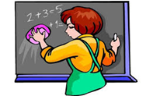
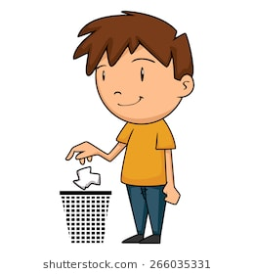
Can you come to the board?
May I clean the board?
Can you point to the board?

May I go to the board?
Can I sharpen my pencil?
Can I put this in the bin?

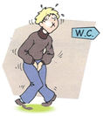

Can I go to the board?
Can I stand up?
May I go to the toilet?
May I close the window?
May I open the window?
May I open the door?
Can I sharpen my pencil?
May I sharpen my pen?
Can I borrow your pencil?

ANSWER KEY

May I come in? Sorry, I’m late.
Can I borrow your pencil?
May I go out?
May I clean the board?
Can I put this in the bin?
Can I sharpen my pencil?
May I go to the toilet?
May I open the window?

