|  |  |  |
| --- | --- | --- |
| **TOPIC: School** | **SUBTOPICS: I like / I don’t like / I love; (S)he likes / (s)he doesn’t like / (s)he loves; school activities** | **LEVEL: A2** |
| **Name:** ____________________________ **Surname:** ____________________________ **Nber: ____ Grade/Class:** _____ | | |

**Expressing likes and dislikes**

|  |  |  |  |
| --- | --- | --- | --- |
|  |  |  |  |
| **I** | I like | I don’t like | I love |
| **(s)he** | (s)he like**s** | (s)he do**es**n’t like | (s)he love**s** |



**Look and write.**

a)

_____________________________



****b)

_____________________________



c)

_____________________________

d)

_____________________________



_____________________________

e)





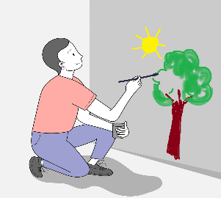

_____________________________

f)