Name: ____________________________ Surname: ____________________________ N^{ber}: ____ Grade/Class: _____
Assessment: _____________________________ | Date: ___________________________________________________
 | Teacher’s signature:  ___________________________ | Parent’s signature:  ___________________________

Unscramble the letters and match.

p o m t c u e r m r o o
c____________ r________
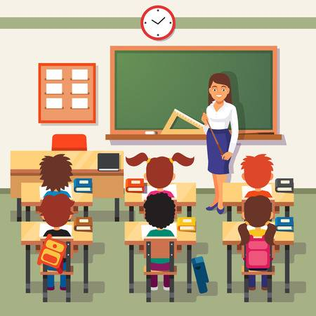
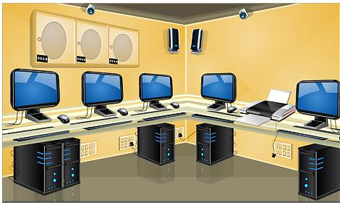
•

•

•

•

•

•

•

•

m y g
g_______________

c m l s s o o r a

c________________
t e e c n a
c_______________

y g a d p l r n o u
p___________________

r y b a r l i
m___________ r________
m i c u s m o o r
a___________ r________
l_________________
r a t m o o r

ANSWER KEY

Computer room
Gym
Classroom
Canteen
Playground
Library
Art room
Music room

