Name: ____________________________ Surname: ____________________________ N^{ber}: ____ Grade/Class: _____
Assessment: _____________________________ | Date: ___________________________________________________
 | Teacher’s signature:  ___________________________ | Parent’s signature:  ___________________________

- Fill in the gaps and match the rubbish to the correct bin.

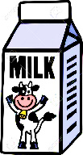
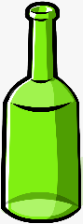

C_ _ t _ _ of _ i _ k
N_ w_ p _ _ e r
G_ _ _ s b_ _ t _e
P_ _ _t _ c b_ _ t _e
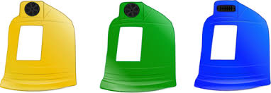
S_ o_ b_ _
C_ _
P _ _ e_
G_ _ _ s j_ _

Blue bin

Green bin

Yellow bin

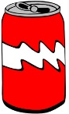
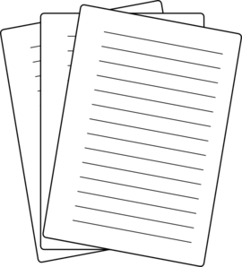

2) Read and complete.
a) glass.
b) plastic and metal.
c) paper and cardboard.

- The yellow bin is for _____________________
- The blue bin is for _______________________
- The green bin is for ______________________

ANSWER KEY

EXERCISE 1
Glass bottle green bin
Carton of milk yellow bin
Newspaper blue bin
Plastic bottle yellow bin
Shoe box blue bin
Can yellow bin
Paper blue bin
Glass jar green bin

EXERCISE 2
- The yellow bin is for plastic and metal.
- The blue bin is for paper and cardboard.
- The green bin is for glass.

