TOPIC: School | SUBTOPICS: Classroom language | LEVEL: A2
Name: ____________________________ Surname: ____________________________ N^{ber}: ____ Grade/Class: _____
Asking for permission / Making simple requests

Match.
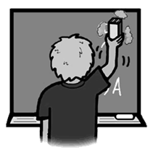
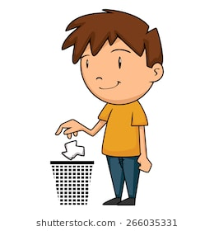
Can you close the door, please?

May I sharpen my pencil?
Can I go to the toilet?
May I clean the board?
Can I put this in the bin?
Can you repeat, please?
Can I come in? Sorry, I’m late.
A F
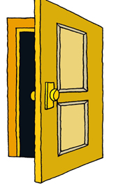
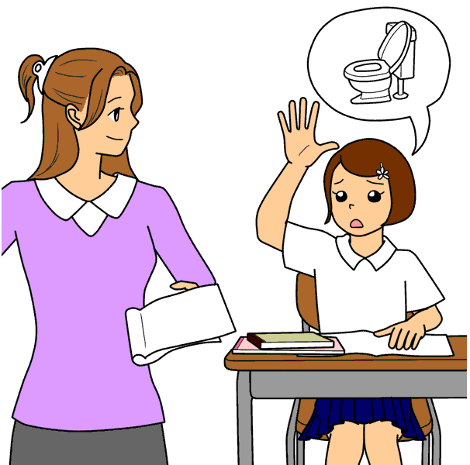

B G

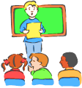

C H

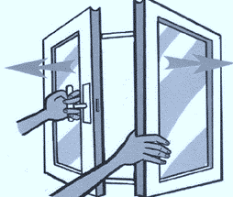
Can I go out?

D I

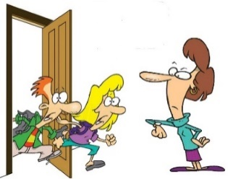
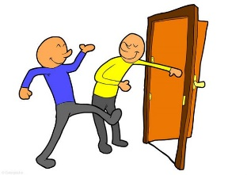
Can you step aside, please?

E J
May I open the window?

