Name: ____________________________ Surname: ____________________________ N^{ber}: ____ Grade/Class: _____
Assessment: _____________________________ | Date: ___________________________________________________
 | Teacher’s signature:  ___________________________ | Parent’s signature:  ___________________________

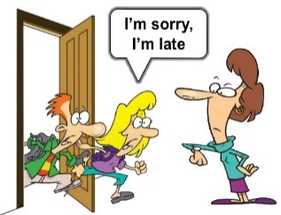
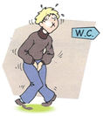
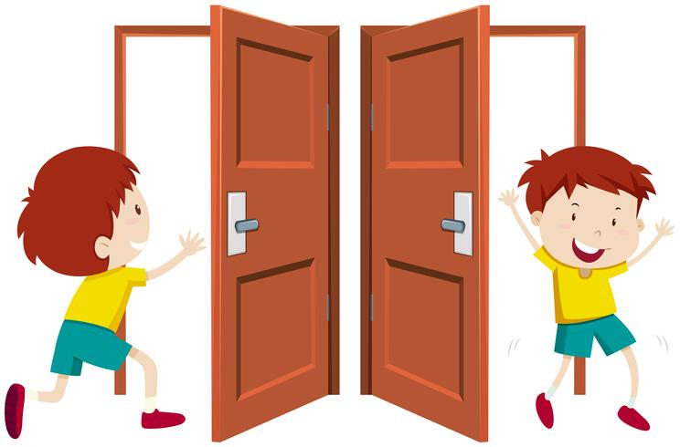
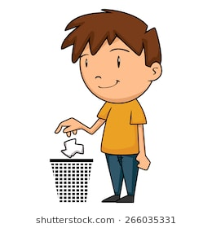
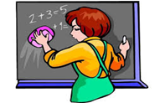
Write and match the pictures.

bin / this / the / Can / I / in / put / ?
may / in / I / come / I’m / Sorry / late / ?
8
4
3
7
6
2
1
5
________________________________
to / toilet / go / I / the / Can / ?
________________________________
clean / board / the / May / I / ?
________________________________
window / Can / open / I / the / ?
________________________________
________________________________
Can / your / pencil / I / borrow / ?
________________________________
my / May / pencil / I / sharpen / ?
________________________________
go / I / can / out / ?

________________________________

ANSWER KEY

Can I go out? – Picture 2
Can I go to the toilet? – Picture 3
May I sharpen my pencil? – Picture 4
Can I borrow your pencil– Picture 1
May I clean the board? – Picture 5
Can I open the window? – Picture 7
Sorry, I’m late, may I come in? – Picture 8
Can I put this in the bin? – Picture 6

