TOPIC: School | SUBTOPICS: places at school; school activities | LEVEL: A2
Name: ____________________________ Surname: ____________________________ N^{ber}: ____ Grade/Class: _____

At school: places and activities

Answer the questions.
p e r t c o m u m o r o
e.g. Where is Luke? What is he doing?

- He is in the computer room. He is playing computer games.

n e t c e n a
- Where is Jim? What is he doing?

- He is in the _____________________. He is e__ t __ __ __ .

l b r y i a r
- Where is Melissa? What is she doing?

- She ____________________________. She _____ r__ a __ i __ __ a book.

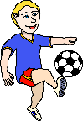
y g m
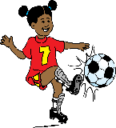
- Where are Kevin and Lisa? What are they doing?

- They ___________________________. They _____ p__ __ y__ __ g f__ __ t __ __ __ l.

s i m u c m o r o
- Where is the Jenny? What is she doing?

- _________________________________. _________________________________.

p y r o l a g u d n
- Where are the twin brothers? What are they doing?

- _________________________________. _________________________________.

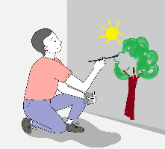
a t r r o m o
- Where is the teacher? What is he doing?

- _________________________________. _________________________________.

a r c l o s s m o
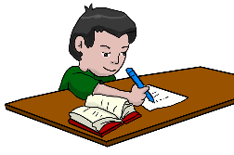
- Where is the Richard? What is he doing?

- _________________________________. _________________________________.

