TOPIC: School | SUBTOPICS: places at school; classroom and playground activities | LEVEL: A2
Name: ____________________________ Surname: ____________________________ N^{ber}: ____ Grade/Class: _____
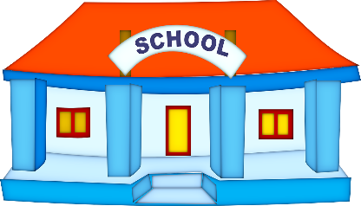
1. Complete the text about your school.

My school is… big small
There is… a library a canteen a music room an art room
a computer room a gym a big playground

There are ________ classrooms.
My friends are… friendly honest respectful amusing kind
My teachers are… hard-working patient caring tough boring
My favourite activities in the classroom are ______________________ and _____________________.
I don’t like __________________________ or ________________________.
In the playground, I like _________________________ and _________________________.
I don’t like ___________________________ or ________________________.

2. Write your text.

___________________________________________________________________________________________________________________________________________________________________________________________________________________________________________________________________________________________________________________________________________________________________________________________________________________________________________________

