Name: ____________________________ Surname: ____________________________ N^{ber}: ____ Grade/Class: _____
Assessment: _____________________________ | Date: ___________________________________________________
 | Teacher’s signature:  ___________________________ | Parent’s signature:  ___________________________

Look at the picture.

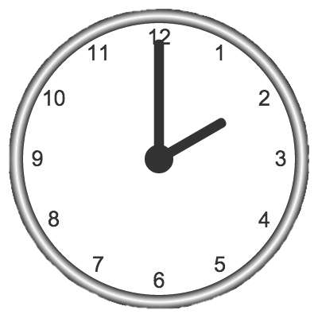

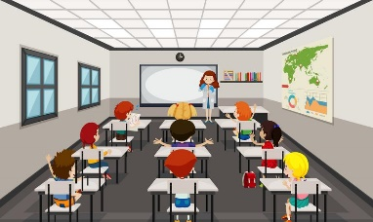

03/05/2020

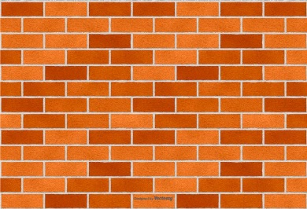

Read the questions and answer.
They _______________________________________.
There _______________________________________.
It’s _________________________________________.
It’s _________________________________________.
There _______________________________________.

- Where are the students?
- How many students are there?
- What time is it?
- What’s the date?
- What can you see near the tree?

ANSWER KEY

- They are in the classroom.
- There are twelve students.
- It’s two o’ clock in the afternoon.
- It’s the third of May.
- There are three recycling bins.

