Name: ____________________________ Surname: ____________________________ N^{ber}: ____ Grade/Class: _____
Assessment: _____________________________ | Date: ___________________________________________________
 | Teacher’s signature:  ___________________________ | Parent’s signature:  ___________________________

Read, look and write.

Today is my first day of 1)_____________________ . I’m in class 4A with my friends James and Susan. My school is great. There’s a big 2)___________________ and a 3)__________________ . There‘s a 4)__________________ where we play football and hide and seek in the interval, and there are eight 5)_______________
There’s an 6)___________________ and a 7)___________________ .
There’s a big 8)_______________________ with twelve computers and there’s a super new 9)______________________ too with lots of books. It’s my favourite part of school. I love 10) ___________________ books. My new school is very cool!

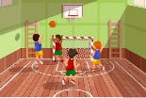

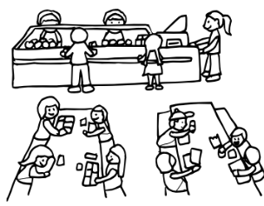
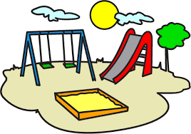

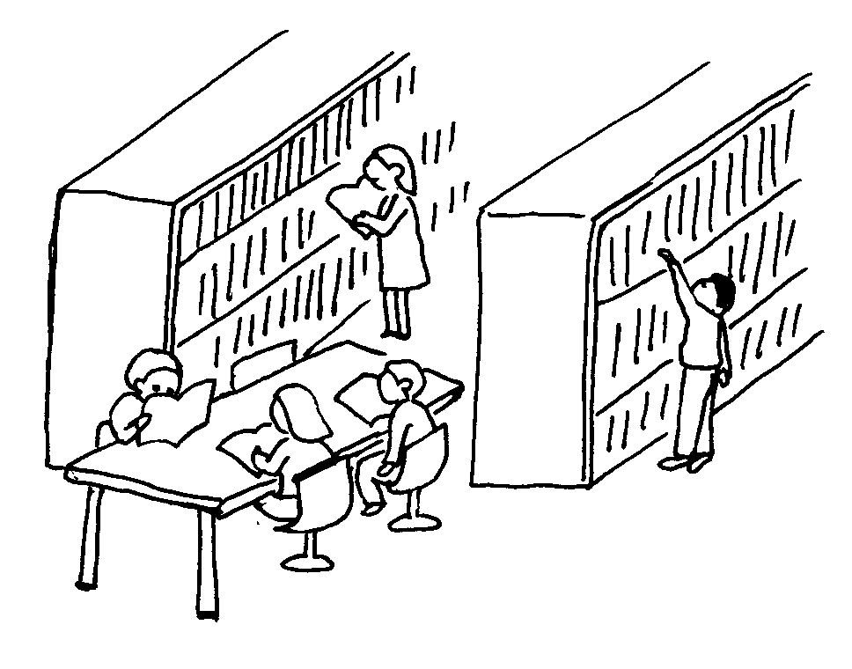
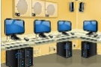

ANSWER KEY

- School
- Gym
- Canteen
- Playground
- Classrooms
- Art room
- Music room
- Computer room
- Library
- Reading

