Name: ____________________________ Surname: ____________________________ N^{ber}: ____ Grade/Class: _____
Assessment: _____________________________ | Date: ___________________________________________________
 | Teacher’s signature:  ___________________________ | Parent’s signature:  ___________________________

1) Read and write about you and your school.

Hello! My name’s ____________________ and I’m ____________ years old.
My school is ______________________________________. (Name of the school)
I’m in class ________.
In the classroom I _ _ _ _ __________________________________ and
________________________________________. (2 classroom activities)
but I _ _ _’t _ _ _ _ ________________________________. (1 classroom activity)
My favourite playground activity is _____________________________.

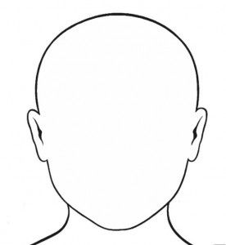

This is me
2) Draw your school and label the different parts of your school.

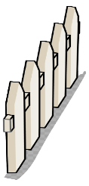
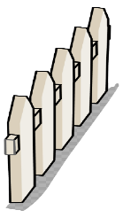
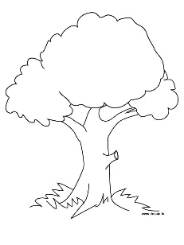

ANSWER KEY
1)
- Student’s name (e.g. Maria)
- Student’s age (e.g. nine)
- Student’s class (e.g. 4B)
- I like + 2 classroom activities (e.g. reading, drawing, listening to music, singing…)
- I don’t like + 1 classroom activity (e.g. writing, painting…)
- 1 Playground activity (e.g. playing football/basketball, playing hopscotch, jumping rope, playing tag, playing hide and seek, playing on the slide, playing on a swing…)
2)
According to the student’s school:
Playground / classroom / library / canteen / computer room / art room / music room / toilets

