Name: ____________________________ Surname: ____________________________ N^{ber}: ____ Grade/Class: _____
Assessment: _____________________________ | Date: ___________________________________________________
 | Teacher’s signature:  ___________________________ | Parent’s signature:  ___________________________

Listen and tick.

- What’s her favourite season?
a) b) c)

30
- How many hats are there?
23
13
a) b) c)

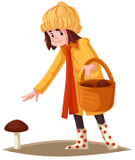
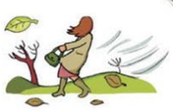

- What is James doing?
a) b) c)

- Where’s the cap?
a) b) c)

- Who is Dave?
a) b) c)

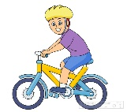
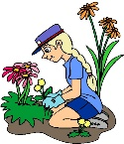
- What’s your favourite spring activity?
a) b) c)

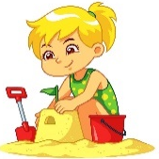
- What is Megan doing?
a) b) c)

TRANSCRIPT

EXERCISE 1

ONE
Boy: What’s your favourite season?
Girl: I like summer, I like going to the beach and building sandcastles. But, my favourite season is winter. I love skiing and throwing snowballs.

TWO
Boy: It’s very hot today. We need hats. How many hats are there?
Girl: 23, I think.

THREE
Girl: It’s windy today. Look, while mum is picking mushrooms James is flying a kite.

FOUR
Boy: Where’s my cap?
Girl: Look over there. It’s near the box.

FIVE
Boy: Look! Dave loves playing in the snow.
Girl: Is he skiing?
Boy: No, he’s on his sledge.

SIX
Boy: What a wonderful day. I love spring.
Girl: So, do I. I like riding my bike but my favourite spring activity is doing the gardening.

SEVEN
Boy: Where is Megan? I can’t see her.
Girl: She’s near the sea.
Boy: Is she building a sandcastle?
Girl: No, she’s collecting seashells.

ANSWER KEY

- b
- a
- b
- b
- c
- a
- c

