Name: ____________________________ Surname: ____________________________ N^{ber}: ____ Grade/Class: _____
Assessment: _____________________________ | Date: ___________________________________________________
 | Teacher’s signature:  ___________________________ | Parent’s signature:  ___________________________
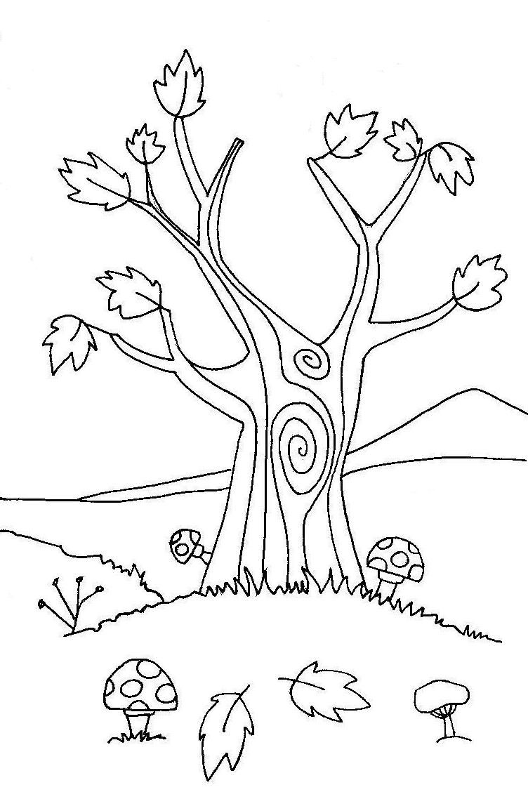
1) Listen and colour.

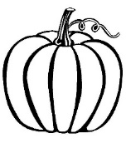
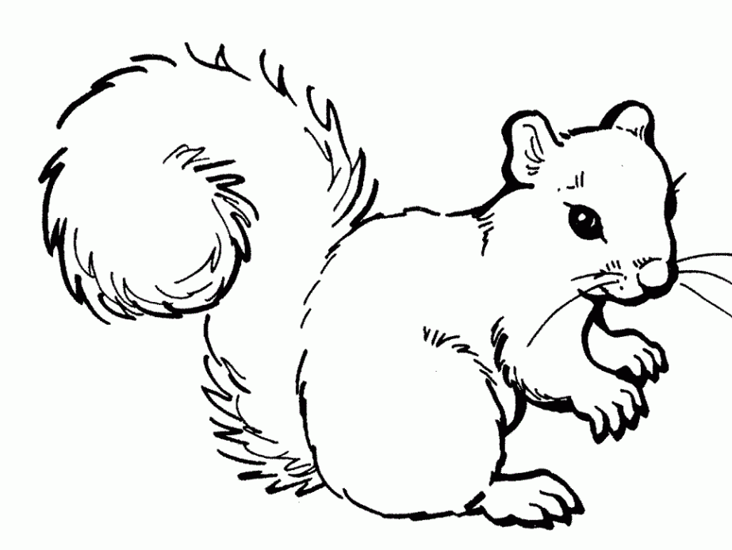

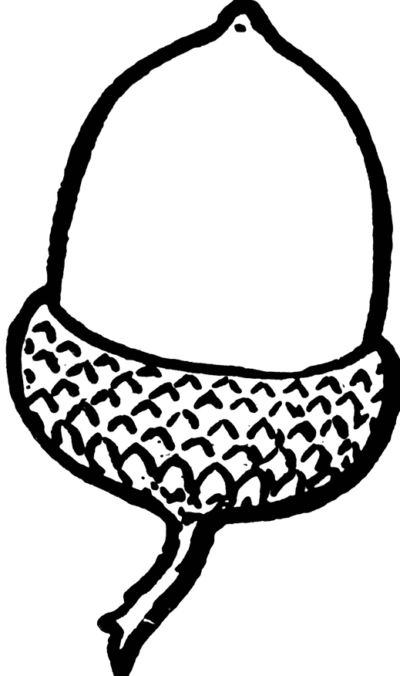
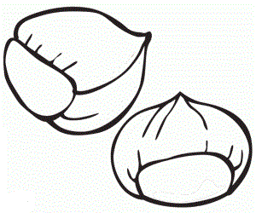

2) Listen and number.
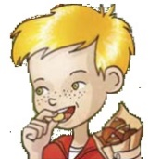

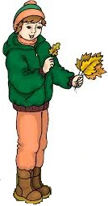
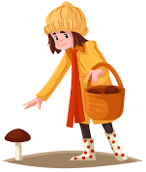
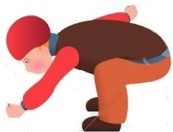

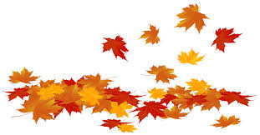

TRANSCRIPT

EXERCISE 1
One
Teacher – Can you see the mushrooms?
Mary – Yes, I can.
Teacher – Colour just one mushroom red.
Mary – Pardon?
Teacher – Colour one mushroom red.
Mary – OK.

Two
Teacher – Look at the squirrel.
Mary – Can I colour it?
Teacher – Yes. Colour the squirrel grey!
Mary – I like grey squirrels.

Three
Teacher – Now colour the chestnuts.
Mary – What colour?
Teacher – Brown.
Mary – Ok. Brown chestnuts.

Four
Teacher – Can you see the pumpkin?
Mary – Yes.
Teacher – Colour the pumpkin yellow.
Mary – Ok, a yellow pumpkin!

Five
Mary – Can I colour the leaves?
Teacher – Yes. Just two. Colour one leaf in yellow and one leaf in green
Mary – One yellow leaf and one green leaf! Finished.

EXERCISE 2
One
I love jumping in a pile of leaves. It’s funny.
Two
I like eating chestnuts in autumn.
Three
My favourite autumn activity is collecting leaves.
Four
It’s windy today. Tim is flying a kite.
Five
Look, Tom is collecting acorns.
Six
In autumn, I like picking mushrooms.

ANSWER KEY

EXERCISE 1
- 1 mushroom – red
- squirrel – grey
- chestnuts – brown
- pumpkin – yellow
- 2 leaves: 1 yellow, 1 green

EXERCISE 2

2 | 1 | 4
3 | 5 | 6

