Name: ____________________________ Surname: ____________________________ N^{ber}: ____ Grade/Class: _____
Assessment: _____________________________ | Date: ___________________________________________________
 | Teacher’s signature:  ___________________________ | Parent’s signature:  ___________________________

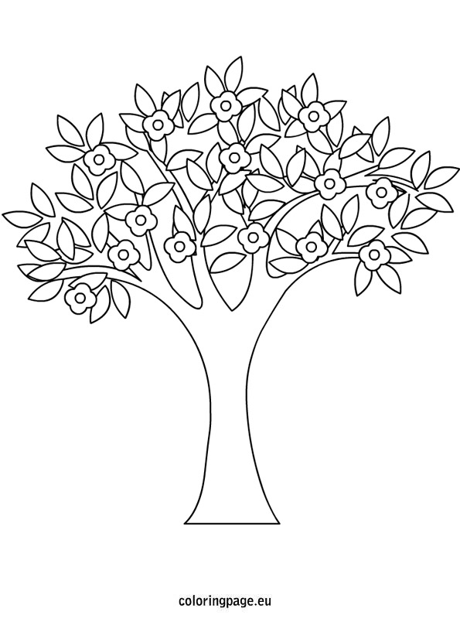
1) Listen and colour.

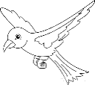

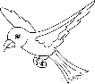

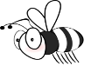
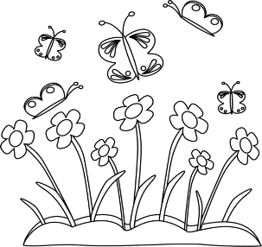

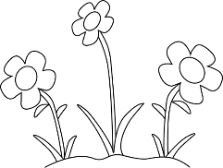
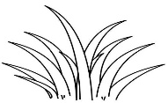
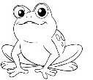
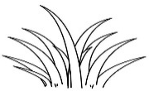

2) Listen and number.
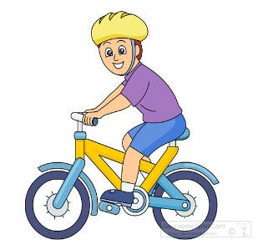
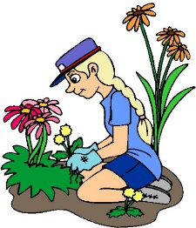
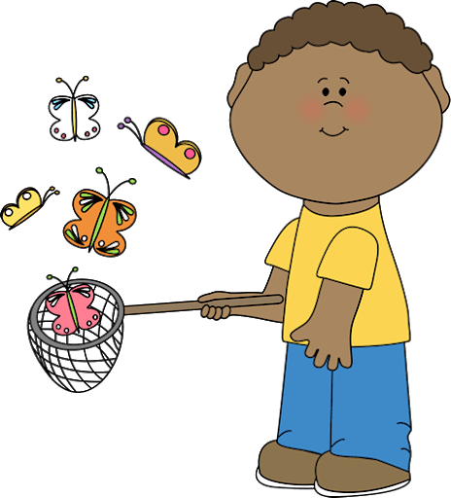

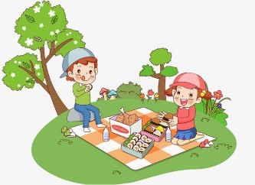

TRANSCRIPT

EXERCISE 1
One
Teacher – Look at the picture. Colour two flowers red.
Jane – Pardon?
Teacher – Colour two flowers red.
Jane – OK.

Two
Teacher – Look at the butterflies.
Jane – Can I colour them?
Teacher – Yes. Colour the butterflies purple!
Jane – I like purple butterflies.

Three
Teacher – Now colour the bee.
Jane – What colour?
Teacher – orange.
Jane – Ok. An orange bee.

Four
Teacher – Can you see the frog?
Jane – Yes.
Teacher – Colour the frog green.
Jane – Ok, a green frog!

Five
Jane – Can I colour the birds?
Teacher – Yes. Colour one bird in yellow and one bird in blue.

EXERCISE 2
One
I love spring, I can catch butterflies.
Two
I’m doing the gardening, it’s warm today.
Three
My favourite spring activity is picking flowers.
Four
I like having a picnic in spring.
Five
Look, Tom is riding a bike.

ANSWER KEY

EXERCISE 1

- 2 flowers – red
- butterflies – purple
- bee – orange
- frog – green
- 2 leaves: 1 yellow, 1 blue

EXERCISE 2

5 / 1 / 2
3 / 4

