Name: ____________________________ Surname: ____________________________ N^{ber}: ____ Grade/Class: _____
Assessment: _____________________________ | Date: ___________________________________________________
 | Teacher’s signature:  ___________________________ | Parent’s signature:  ___________________________

1) Listen and number.
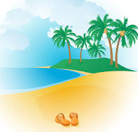

2) Listen and tick.
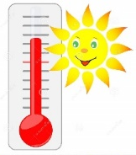
- What’s the weather like?
a) b) c)

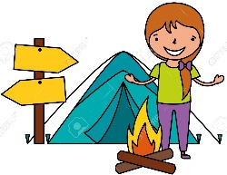
- Who is Jessica?
a) b) c)

- How many seashells have you got?
23
15
30
a) b) c)

- Where’s the cap?
a) b) c)

- What is Mike doing?
a) b) c)

TRANSCRIPT

EXERCISE 1

- sun
- boat
- beach
- ice cream
- sea
- sand

EXERCISE 2
1)
BOY: It’s sunny and very hot. I love summer.
2)
BOY: Where’s Jessica?
GIRL: Look, there’s Jessica. She’s eating a chocolate ice cream.
3)
BOY: So many seashells... How many seashell have you got?
GIRL: Thirty.
4)
BOY: Where’s my cap? I can’t find it!
GIRL: Look, it’s over there, on the chair.
5)
BOY: Is Mike building a sandcastle?
GIRL: No, he’s swimming in the sea.

ANSWER KEY

EXERCISE 1

4 / 3 / 1 / 5 / 6 / 2

EXERCISE 2

- a
- b
- a
- a
- c

