Name: ____________________________ Surname: ____________________________ N^{ber}: ____ Grade/Class: _____
Assessment: _____________________________ | Date: ___________________________________________________
 | Teacher’s signature:  ___________________________ | Parent’s signature:  ___________________________

1) Listen and number.

2) Listen and tick.
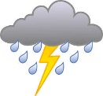
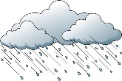
*
- What’s the weather like? * *
a) b) c)

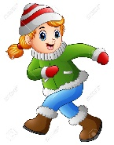
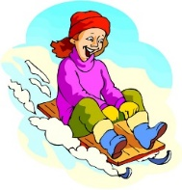
- Who is Jessica?
a) b) c)

- How many sledges are there?
23
30
13
a) b) c)

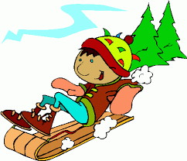
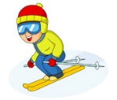
- What’s Peter doing?
a) b) c)

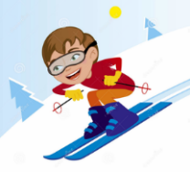
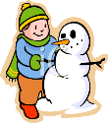
- What’s your favourite winter activity?
a) b) c)

TRANSCRIPT

EXERCISE 1

- Snowflake
- Snowman
- Umbrella
- Sledge
- Ice
- snow

EXERCISE 2
1)
BOY: Brr! It’s very cold and snowy today. I don’t like winter.
2)
BOY: Where’s Jessica?
GIRL: Look, there’s Jessica. She’s drinking hot chocolate.
3)
BOY: The children want to play in the snow. How many sledges are there?
GIRL: Hum… twenty-three.
4)
BOY: Where’s Peter?
GIRL: Peter? He’s over there, He’s making a snowman.
5)
BOY: What’s your favourite winter activity?
GIRL: Well, I like sledging and making a snowman but my favourite activity is skiing

ANSWER KEY

EXERCISE 1
5 / 1 / 4 / 6 / 2 / 3

EXERCISE 2
- c
- a
- b
- b
- c

