TOPIC: Seasons | SUBTOPICS: vocabulary related to autumn; weather; colours; numbers | LEVEL: A1
Name: ____________________________ Surname: ____________________________ N^{ber}: ____ Grade/Class: _____

Autumn days

1) Look at the picture. Read the questions and circle the correct answers.

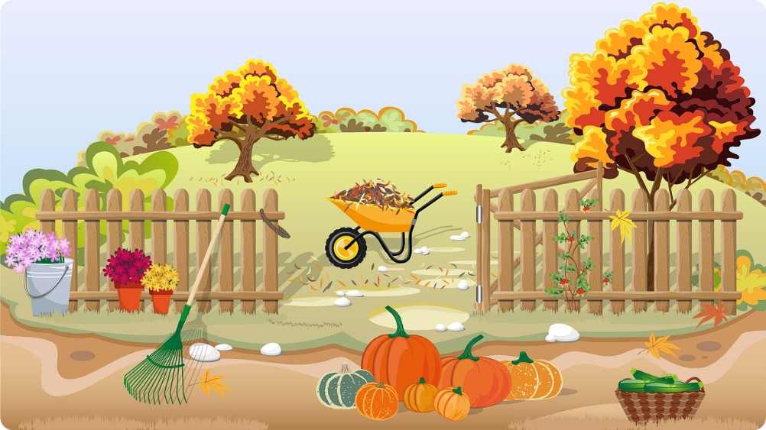

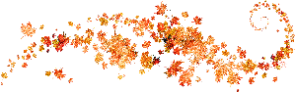

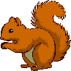
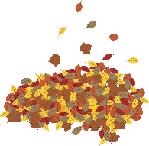

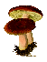

- What’s the season?
It’s autumn It’s winter It’s spring It’s summer

- What’s the weather like?
It’s sunny It’s cloudy It’s rainy It’s chilly It’s hot It’s windy

- What colour are autumn leaves?
yellow grey orange red blue green brown

- How many trees are there?
one tree two trees three trees four trees

- How many pumpkins are there?
five pumpkins six pumpkins seven pumpkins eight pumpkins
1) Read and colour.

a) The leaves on the tree are green and yellow.
b) The acorn is brown.
c) There are two pumpkins: one is orange and one is yellow.
d) The squirrel is grey.
e) There are two mushrooms: one is red and one is orange.
f) The chestnuts are brown.
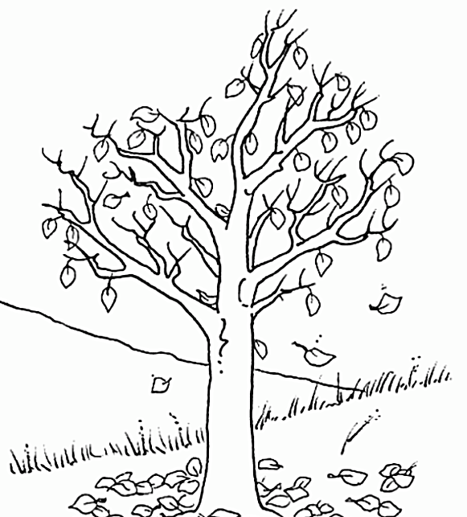
e) The clouds are grey.
