Name: ____________________________ Surname: ____________________________ N^{ber}: ____ Grade/Class: _____
Assessment: _____________________________ | Date: ___________________________________________________
 | Teacher’s signature:  ___________________________ | Parent’s signature:  ___________________________

1) Read and look at the picture. Write Yes or No.
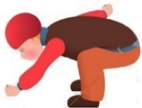
- Clouds are grey. ______ d) He’s collecting leaves. ______
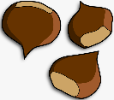
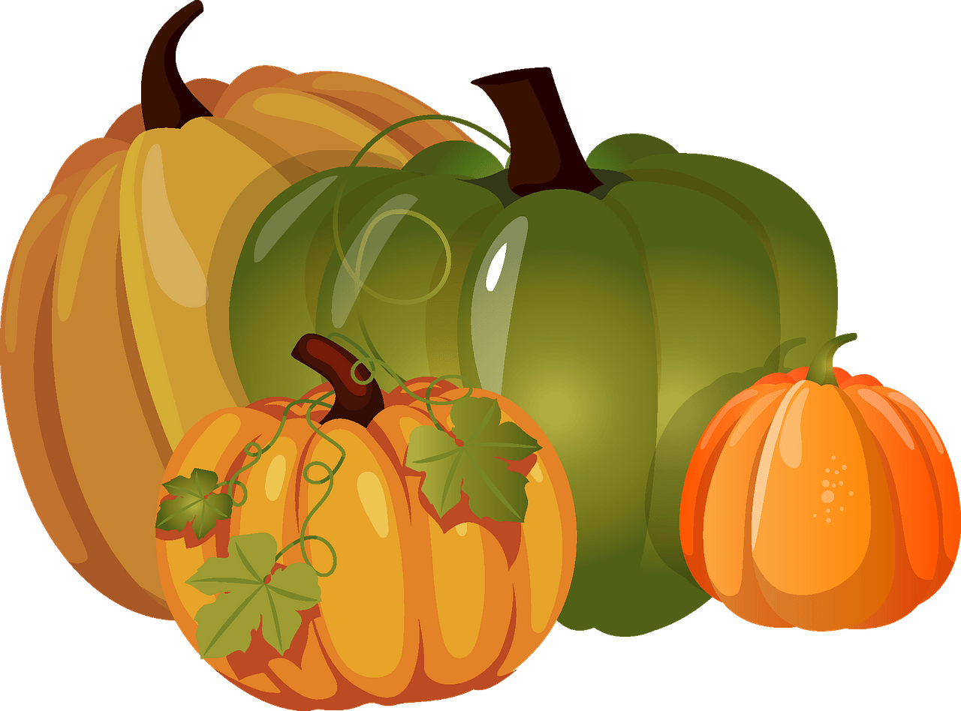
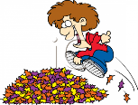
- There are three pumpkins. ______ e) Chestnuts are brown. ______
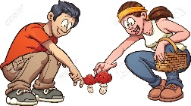

- They’re picking mushrooms. ______ f) He’s jumping in a pile of acorns. ______

2) Read and Match.

- It’s rainy.
- Eating chestnuts.
- It’s autumn.
- Yellow and orange.
- Near the pumpkins.
- Fifteen.

- What’s the season?

- What’s the weather like?

- What is he doing?

- What colour are leaves?

- How many mushrooms have you got?

- Where are the chestnuts?
ANSWER KEY

EXERCISE 1

- Yes
- No
- Yes
- Yes
- Yes
- No

EXERCISE 2

- C
- A
- B
- D
- F
- E

