TOPIC: Seasons | SUBTOPICS: vocabulary related to spring; weather; colours; clothes | LEVEL: A1
Name: ____________________________ Surname: ____________________________ N^{ber}: ____ Grade/Class: _____

Look at the picture.

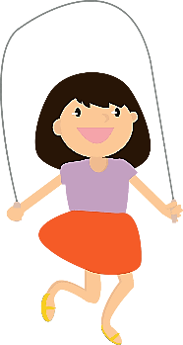
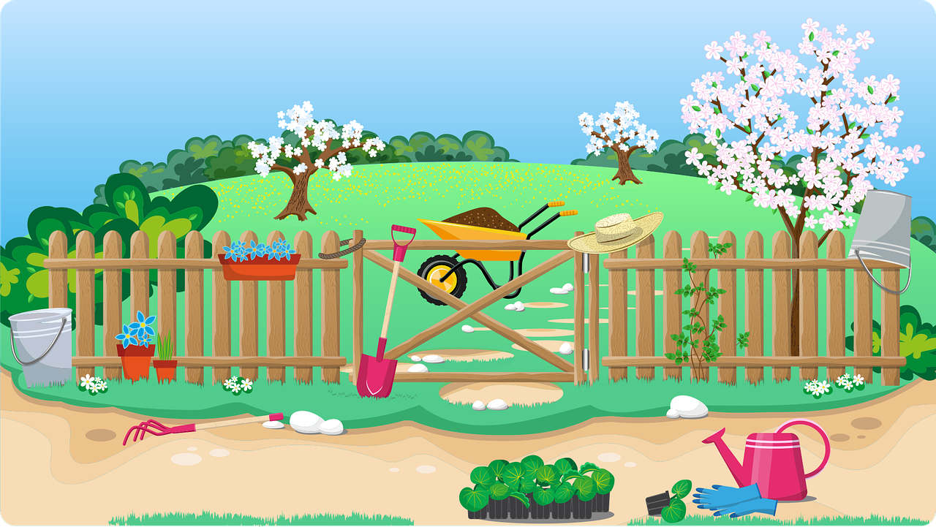
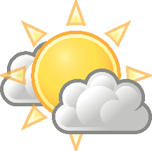

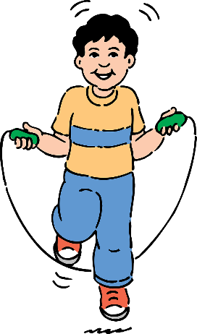
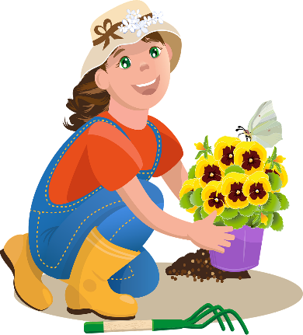

1) Answer the questions.
It’s __________________.
It’s _______________ and ________________.
There are _________ __________________.
They are ____________________.
- What’s the season?
- What’s the weather like?
- How many children are there?
- What colour are the flowers on the trees?

2) Write yes or no.

- The mother is gardening. ______
- The grass is green. ______
- The boy is riding a bike. ______
- The girl is catching butterflies. ______
- The boy is wearing a T-shirt and trousers. ______
- The girl is wearing a dress. ______

