TOPIC: Seasons | SUBTOPICS: winter; weather; winter activities | LEVEL: A1
Name: ____________________________ Surname: ____________________________ N^{ber}: ____ Grade/Class: _____
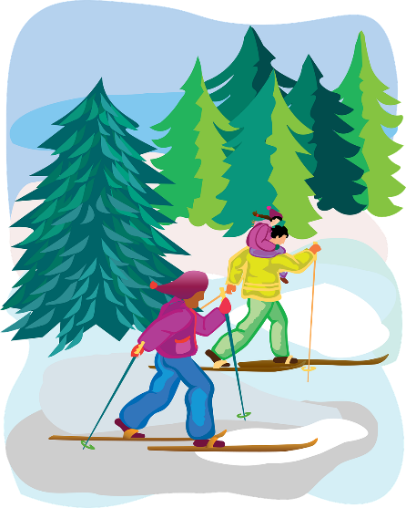
Read.
Hello! My name’s Margaret Costner. I’m eight years old and I’m Scottish.
My favourite season is winter. I love skiing with my father and my mother but I hate running in the snow.
I’ve got a sister, her name’s Jane and she’s six. When it’s snowy my sister and I like throwing snowballs. It’s very funny.

- Complete with the girl’s information.
Name:  ________________ | Surname:  ________________ | Age:  ________________ | Nationality:  ________________

- Read and write True or False.

b.1) Margaret likes running in the snow. ________
b.2) Margaret has got a sister. ________
b.3) They like throwing snowballs when it’s rainy. ________

- Read the questions. Write one-word answers.

c.1) What is Margaret’s favourite season? _________________
c.2) What does she love doing in winter? _________________
c.3) How old is Margaret’s sister? _________________

d) Match.
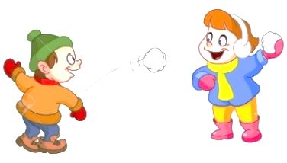
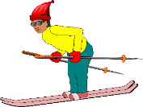

Running in the snow | skiing | Throwing snowballs

