Name: ____________________________ Surname: ____________________________ N^{ber}: ____ Grade/Class: _____
Assessment: _____________________________ | Date: ___________________________________________________
 | Teacher’s signature:  ___________________________ | Parent’s signature:  ___________________________

1) Read and look at the picture. Write Yes or No.
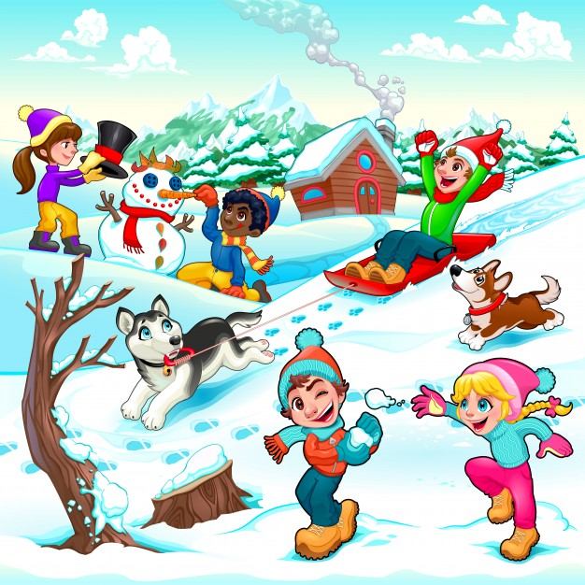
a) It’s winter. _______
b) It’s rainy and freezing. _______
c) There are five children. _______
Jim
d) The snowman is wearing a scarf. _______
e) There is snow. _______
f) Kate and Jim are throwing snowballs. _______
g) Jim is riding a car. _______
h) Two children are making a snowman. _______
Tom
Kate

2) Read and fill in the gaps.
winter name chocolate snowman eleven snowy skiing snow

My (1) ________________ is Mark.
I’m (2) ________________years old.
Today it’s (3) ________________ and I’m making a (4) ________________.
My favourite season is (5) ________________. I love (6) ________________ and drinking hot (7) ________________ but I hate running in the (8) ________________.

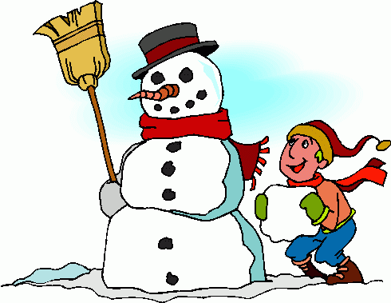

ANSWER KEY

EXERCISE 1

- Yes
- No
- Yes
- Yes
- Yes
- No
- No
- Yes

EXERCISE 2

- name
- eleven
- snowy
- snowman
- winter
- skiing
- chocolate
- snow

