Name: ____________________________ Surname: ____________________________ N^{ber}: ____ Grade/Class: _____
Assessment: _____________________________ | Date: ___________________________________________________
 | Teacher’s signature:  ___________________________ | Parent’s signature:  ___________________________
Group discussion
- Identify the different seasons and describe how the weather is in each season.
- Say what you like, don´t like, hate or love doing in each season.

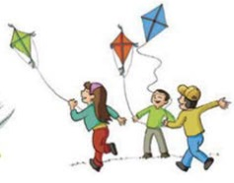
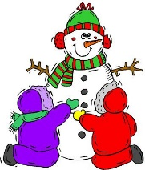
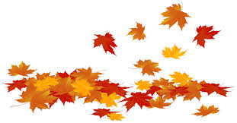
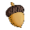
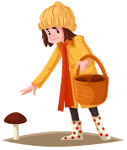
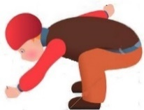

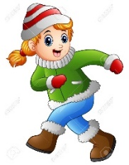
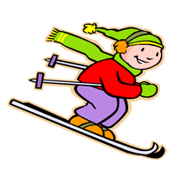
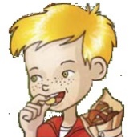
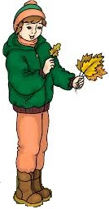

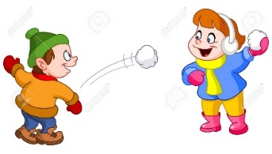
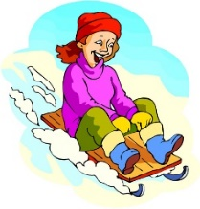

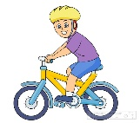
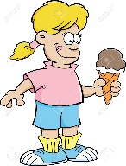

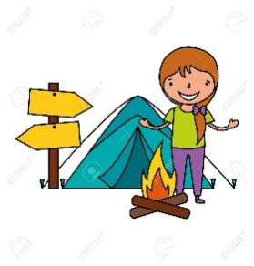
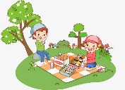

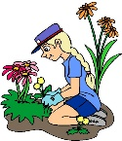
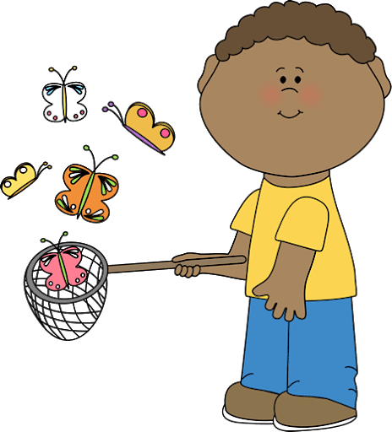

ANSWER KEY

It’s autumn.  In autumn it’s cloudy, windy, sunny or rainy and chilly.  I like… / don’t like… / hate… / love…  - Collecting acorns;  - Flying a kite;  - Picking mushrooms;  - Eating chestnuts;  - Collecting leaves;  - Jumping in a pile of leaves. | It’s winter.  In winter it’s cloudy, rainy or snowy and very cold or freezing.  I like… / don’t like… / hate… / love…  - Making a snowman;  - Drinking hot chocolate;  - Skiing;  - Running in the snow;  - Riding a sledge;  - Throwing snowballs.
It’s spring.  In spring it’s sunny or cloudy and mild or warm.  I like… / don’t like… / hate… / love…  - Picking flowers;  - Riding a bike;  - Having a picnic;  - Catching butterflies;  - Doing the gardening. | It’s summer.  In summer it’s sunny and very hot.  I like… / don’t like… / hate… / love…  - Eating ice cream;  - Swimming;  - Camping;  - Building sandcastles;  - Collecting seashells.

