Name: ____________________________ Surname: ____________________________ N^{ber}: ____ Grade/Class: _____
Assessment: _____________________________ | Date: ___________________________________________________
 | Teacher’s signature:  ___________________________ | Parent’s signature:  ___________________________

Look at the picture.
Answer the questions.
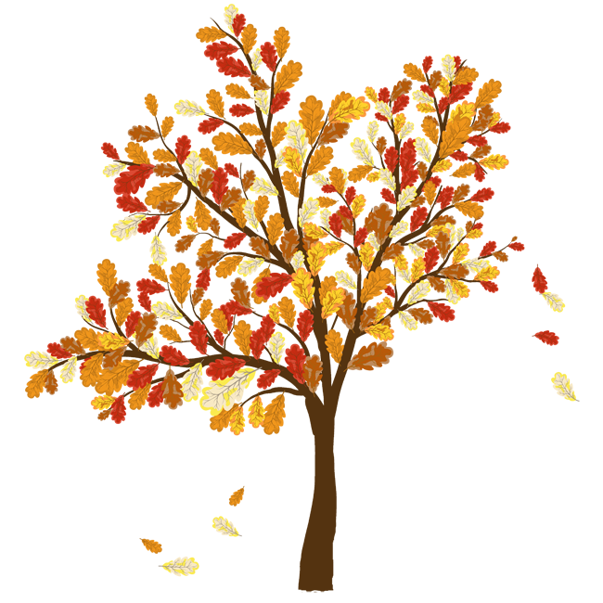

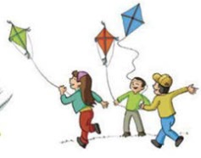

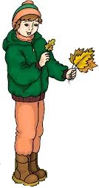

KATE
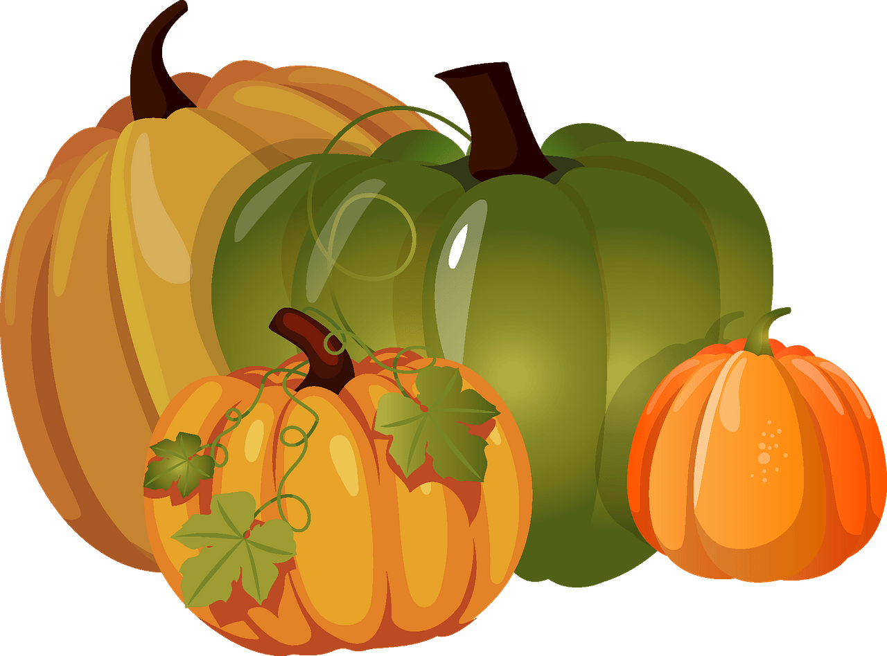
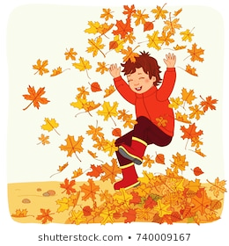
SALLY
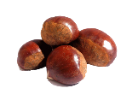
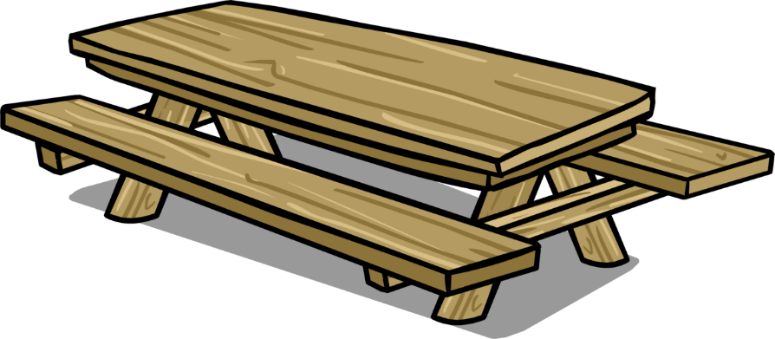
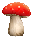
JACK
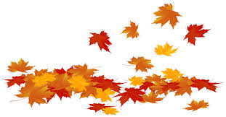
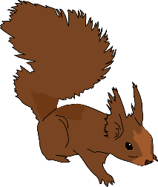
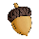

TEACHER’S QUESTIONS:

- What‘s the weather like?
- What season is it? Why? What can you see?
- How many pumpkins are there? / Chestnuts / acorns / mushrooms?
- What colour are autumn leaves?
- What colour is the squirrel?
- What is Jack doing? / Kate / Sally / The children in the background?
- What’s your favourite autumn activity?/

ANSWER KEY
- It’s cloudy, windy and chilly.
- It’s autumn. Leaves are changing colour. Leaves are falling down.
- There are four pumpkins. / four chestnuts. / three acorns. / three mushrooms.
- Autumn leaves are yellow, orange, red and brown.
- It is brown.
- Jack is jumping in a pile of leaves. / Kate is picking mushrooms. / Sally is collecting leaves. / The children in the background are flying a kite.
- My favourite autumn activity is… eating chestnut. / I like… flying a kite

