Name: ____________________________ Surname: ____________________________ N^{ber}: ____ Grade/Class: _____
Assessment: _____________________________ | Date: ___________________________________________________
 | Teacher’s signature:  ___________________________ | Parent’s signature:  ___________________________

Find the 6 differences.

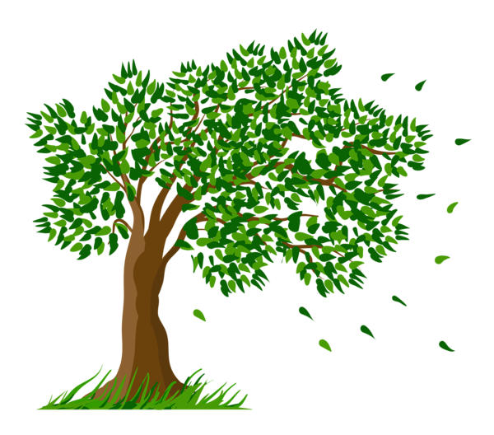

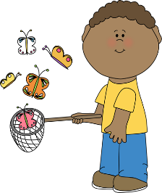
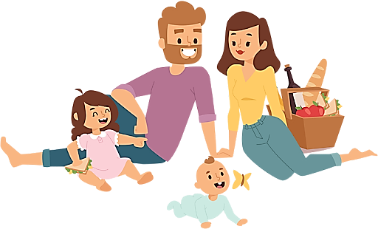
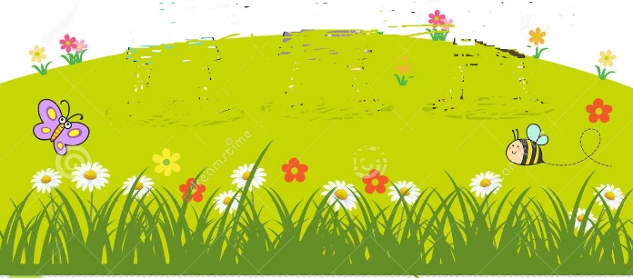
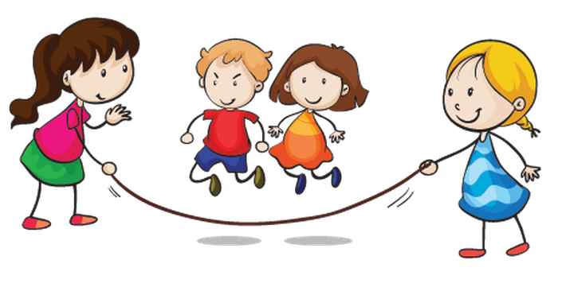

Name: ____________________________ Surname: ____________________________ N^{ber}: ____ Grade/Class: _____
Assessment: _____________________________ | Date: ___________________________________________________
 | Teacher’s signature:  ___________________________ | Parent’s signature:  ___________________________
Find the 6 differences.

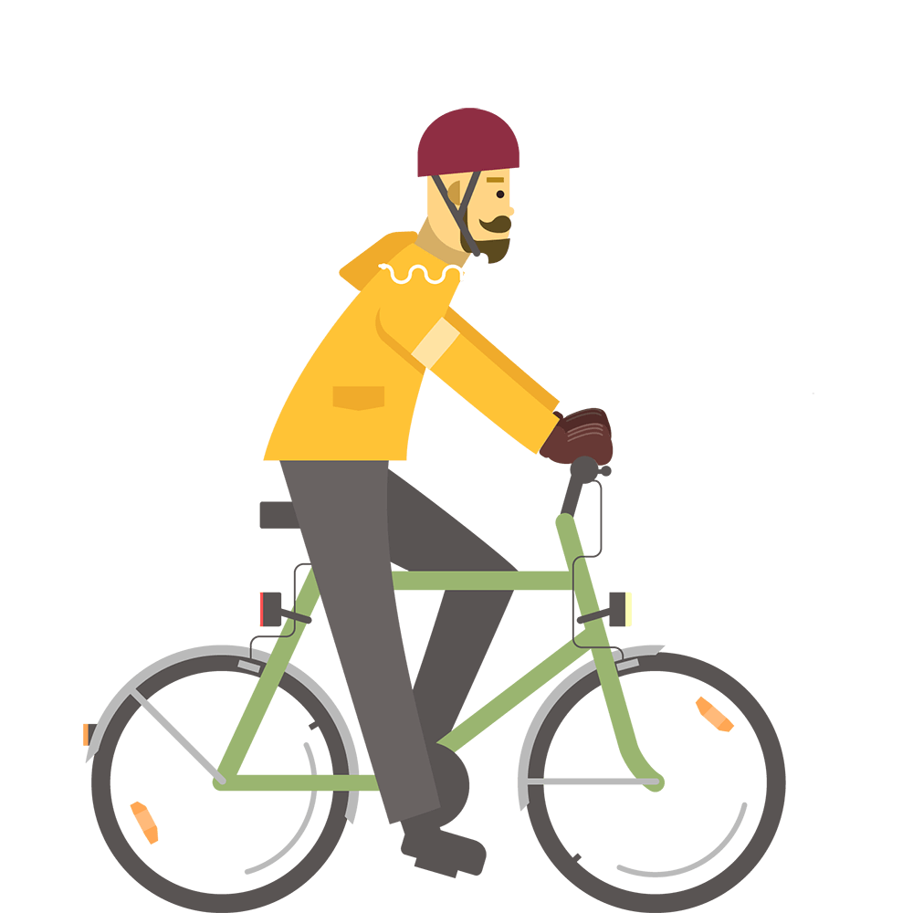

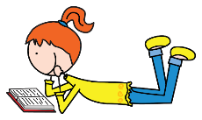

KEY ANSWER

 | PICTURE 1 | PICTURE 2
1 | It is sunny. | It is cloudy.
2 | There is one cloud. | There are two clouds.
3 | There are two birds. | There are three birds.
4 | A girl is riding a bike. | A man is riding a bike.
5 | A boy is catching butterflies. | A boy is playing football.
6 | Children are jumping rope. | One girl is reading a book.

