Name: ____________________________ Surname: ____________________________ N^{ber}: ____ Grade/Class: _____
Assessment: _____________________________ | Date: ___________________________________________________
 | Teacher’s signature:  ___________________________ | Parent’s signature:  ___________________________

Look at the picture.
Answer the questions.
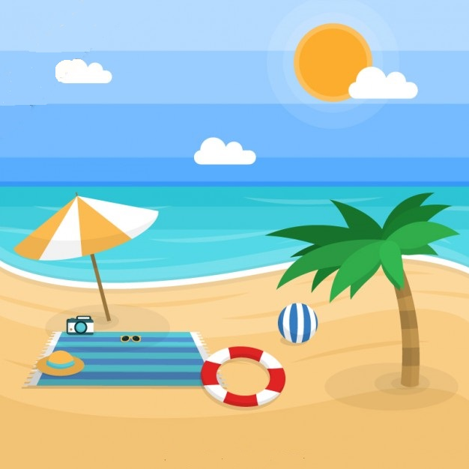

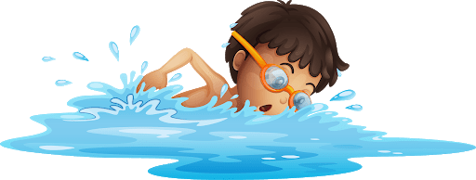
MIKE
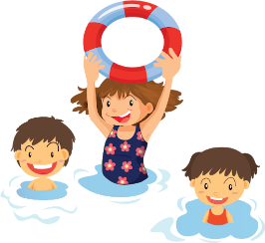

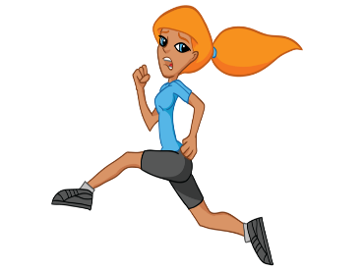

KATE

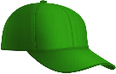
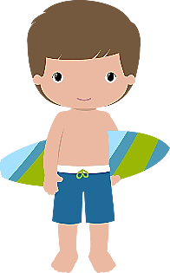
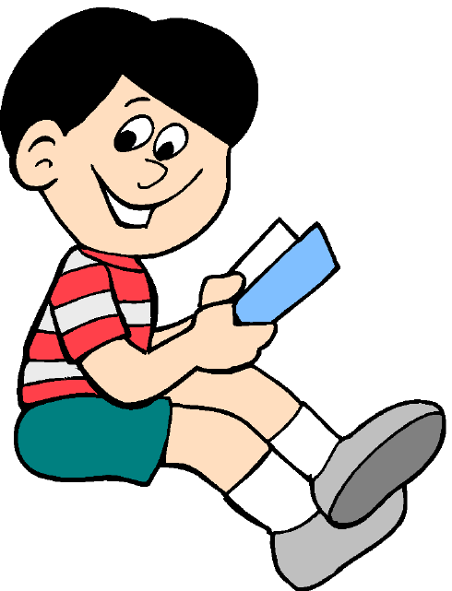
SAM
JACK

TEACHER’S QUESTIONS:

- Where are the people?
- What season is it?
- What‘s the weather like?
- How many children are in the sea?
- What is Sam doing?
- What is Jack doing? What is he wearing?
- What is Mike doing?
- What is Kate doing?
- Where are the sunglasses?
- What is your favourite summer activity?

ANSWER KEY

- They are at the beach.
- It’s summer.
- It’s sunny and very hot.
- There are four children in the sea.
- Sam is building a sandcastle.
- Jack is reading. He’s wearing a T-shirt, shorts, a cap, socks and trainers.
- Mike is swimming.
- Kate is running.
- The sunglasses are on the sand, next to the flip flops.
- My favourite summer activity is swimming.

