Name: ____________________________ Surname: ____________________________ N^{ber}: ____ Grade/Class: _____
Assessment: _____________________________ | Date: ___________________________________________________
 | Teacher’s signature:  ___________________________ | Parent’s signature:  ___________________________

Look at the picture.
Answer the questions.

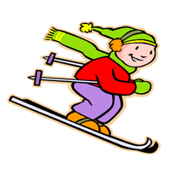
MIKE

SAM

JACK

KATE
MARY

TEACHER’S QUESTIONS:

- What‘s the weather like?
- What season is it?
- What colour is the snow?
- What are Kate and Mary doing?
- What is Mikes doing? Jack? Sam?
- How many sledges are there?
- What winter activity do you love / hate?/

ANSWER KEY
- It’s snowy and freezing/very cold.
- It’s winter.
- It’s white.
- Kate and Mary are making a snowman.
- Mike is skiing. / Jack is riding a sledge. / Sam is throwing snowballs.
- There are two sledges.
- I love skiing and I hate making snowballs.

