|  |  |  |
| --- | --- | --- |
| **Name:** ____________________________ **Surname:** ____________________________ **Nber: ____ Grade/Class:** _____ | | |
| **Assessment:** _____________________________ | **Date:** ___________________________________________________ | |
| **Teacher’s signature:**  **___________________________** | **Parent’s signature:**  **___________________________** |

**1) Label the pictures.**

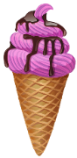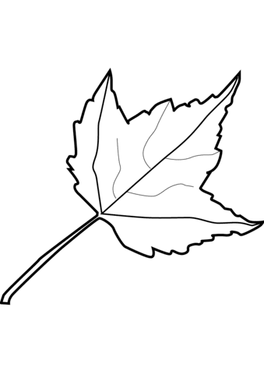

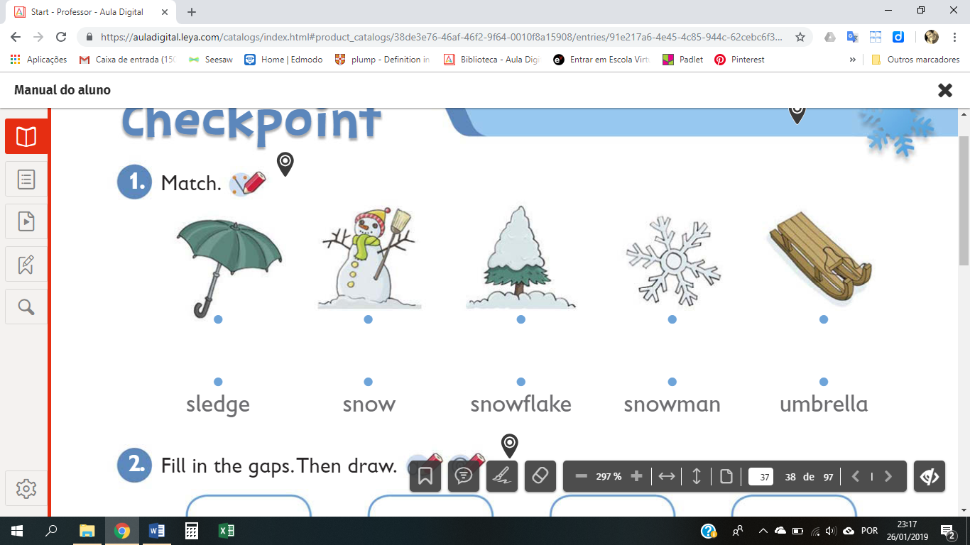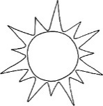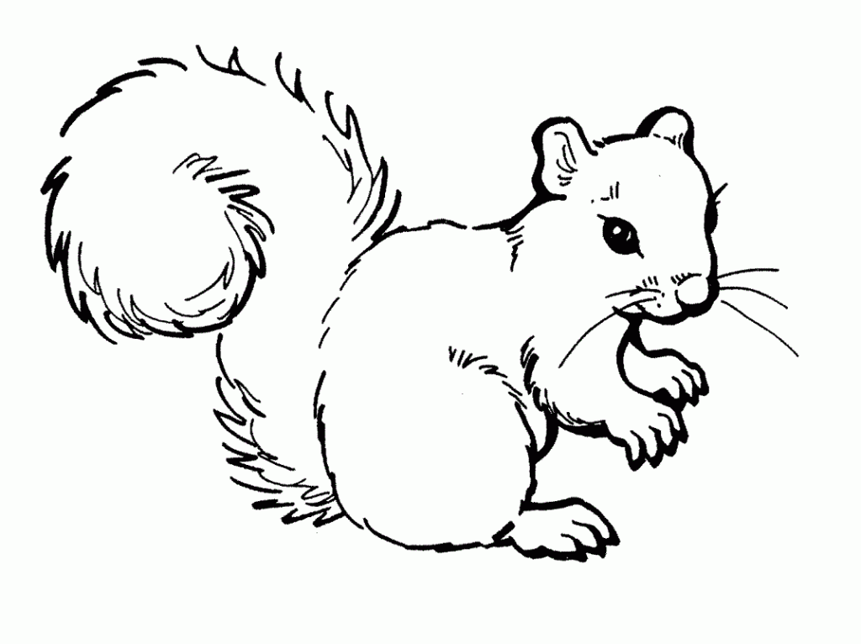



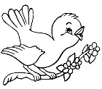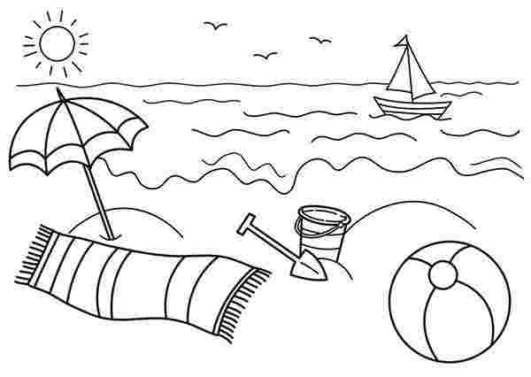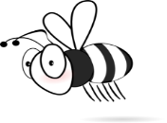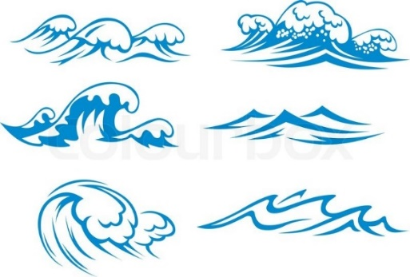

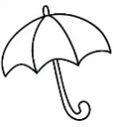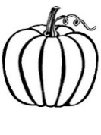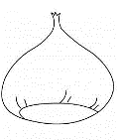

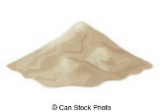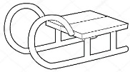

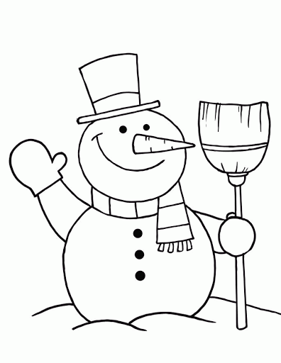

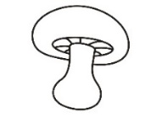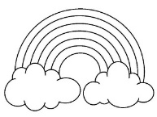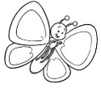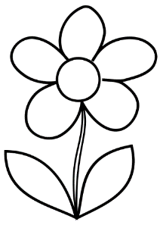

1. chestnut 2. snow 3. butterfly 4. sun 5. Ice cream 6. bird 7. bee 8. leaf

9. flower 10. sand 11. snowman 12. Sledge 13. squirrel 14. sea 15. snowflake

16. umbrella 17. rainbow 18. pumpkin 19. beach 20. mushroom

**2) Write the words in the correct box.** 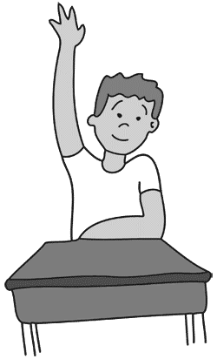

**Winter**

**Spring**

**Summer**

**Autumn**

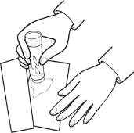

G E  
U L

__________________

__________________

__________________

__________________

__________________

__________________

__________________

__________________

__________________

__________________

__________________

__________________

__________________

__________________

__________________

__________________

__________________

__________________

__________________

__________________

**ANSWER KEY**

**EXERCISE 1**

|  |  |  |  |  |
| --- | --- | --- | --- | --- |
| 8 | 15 | 5 | 4 | 13 |
| 2 | 7 | 14 | 6 | 19 |
| 10 | 1 | 18 | 16 | 12 |
| 20 | 9 | 3 | 11 | 17 |

**EXERCISE 2**

**Autumn**

**Winter**

**Spring**

**Summer**

Snow

Snowman

Sledge

Snowflake

Umbrella

Butterfly

Rainbow

Bird

Bee

Flower

Ice cream

Sand

Sea

Beach

Sun

Chestnut

Leaf

Squirrel

Pumpkin

Mushroom