Name: ____________________________ Surname: ____________________________ N^{ber}: ____ Grade/Class: _____
Assessment: _____________________________ | Date: ___________________________________________________
 | Teacher’s signature:  ___________________________ | Parent’s signature:  ___________________________

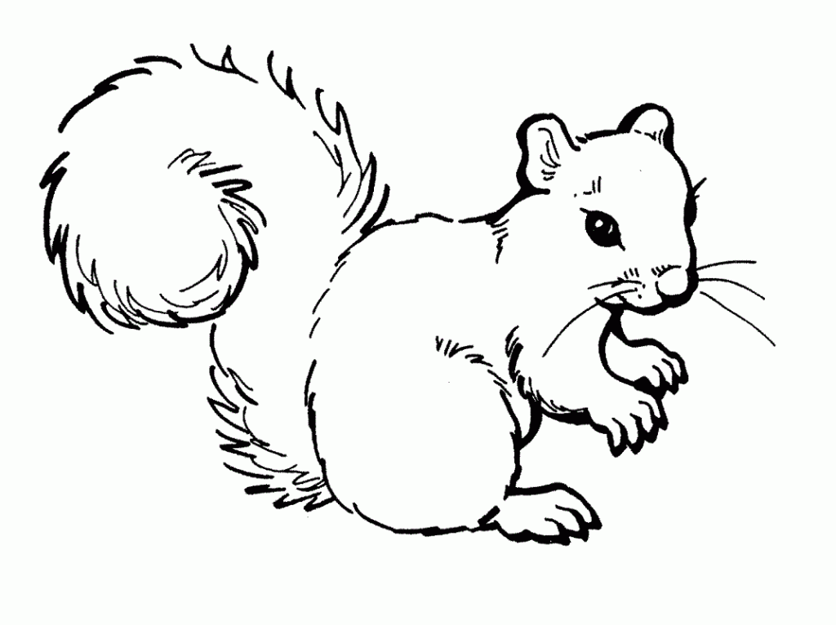
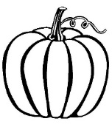
1) Match.

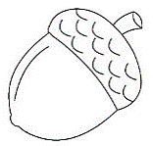

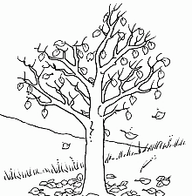
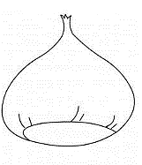
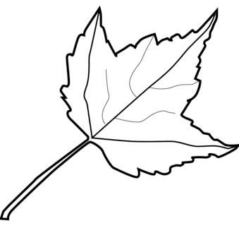
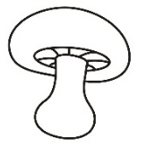

1. Acorn 2. Chestnut 3. Mushroom 4. Squirrel 5. Tree 6. Leaf 7. Pumpkin 8. Cloud

2) Complete.

SINGULAR | PLURAL
acorn  _______________  mushroom  squirrel  _______________  leaf  _______________  pumpkin | _______________  chestnuts  _______________  _______________  trees  _______________  clouds  _______________

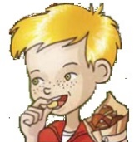
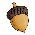
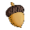
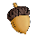
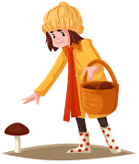
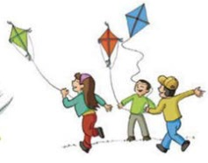
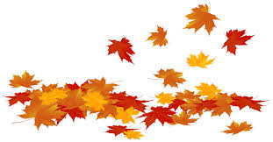
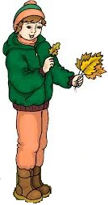
3) Match.
- Eating chestnuts
- Picking mushrooms
- Collecting leaves
- Collecting acorns
- Flying a kite
- Jumping in a pile of leaves

ANSWER KEY
EXERCISE 1
1 | 8 | 7 | 4
2 | 5 | 3 | 6

EXERCISE 2
acorn – acorns
chestnut – chestnuts
mushroom – mushrooms
squirrel – squirrels
tree – trees
leaf – leaves
cloud – clouds
pumpkin – pumpkins

EXERCISE 3
6
4
2
3
5
1
- Eating chestnuts
- Picking mushrooms
- Collecting leaves
- Collecting acorns
- Flying a kite
- Jumping in a pile of leaves

