Name: ____________________________ Surname: ____________________________ N^{ber}: ____ Grade/Class: _____
Assessment: _____________________________ | Date: ___________________________________________________
 | Teacher’s signature:  ___________________________ | Parent’s signature:  ___________________________

1) Write and Match.
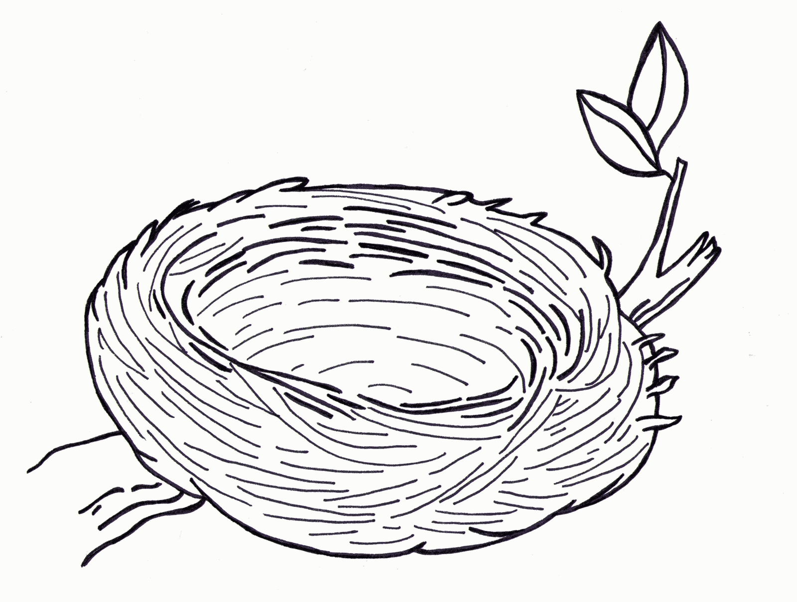
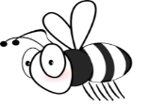
- B __ __
- __ u t t __ r __ __ __
- __ a i __b __ __
- F __ow __ __
- __ r __ ss
- N __ s __
- __ r __g
- B __ r __

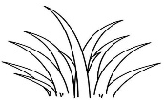
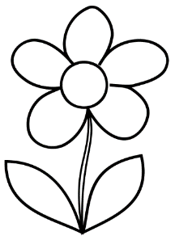

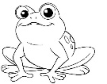

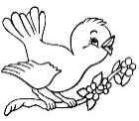

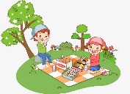
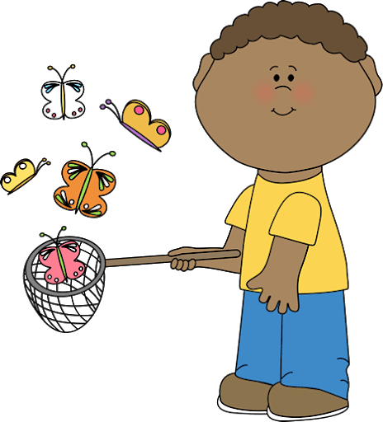
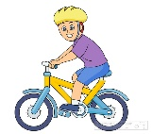
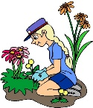
2) Match.
- picking …

- doing…

- having…

- riding…

- catching…
… a bike

… butterflies

… the gardening

… a picnic

… flowers

ANSWER KEY

EXERCISE 1
- Bee
- Butterfly
- Rainbow
- Flower
- Grass
- Nest
- Frog
- Bird
1
6

5
4

7
3

8
2

EXERCISE 2
- picking …

- doing…

- having…

- riding…

- catching…
… a bike

… butterflies

… the gardening

… a picnic

… flowers

