Name: ____________________________ Surname: ____________________________ N^{ber}: ____ Grade/Class: _____
Assessment: _____________________________  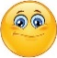 | Date: ___________________________________________________
 | Teacher’s signature:  ___________________________ | Parent’s signature:  ___________________________

- Look at the pictures, unscramble and write.
e c i
m c e a r
a e
s
u n
s

- ______________ b) _______________ c) ________ _______

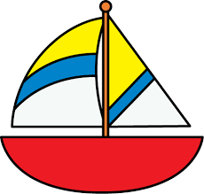
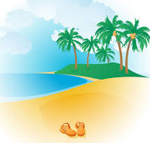
o a
b t
c b h
a e
a s
n d

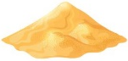

d) _______________ e) ________________ f) ________________

2) Fill in the gaps. Then match.

1
2
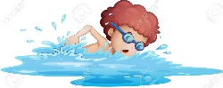
- He’s __ w __m __ i __ g.

- She’s eating i__ __ c __ e __ __ .

- They’re building a s __ __ d __ a s __ l e.
3

- They’re going c__ __ p__ __ g.
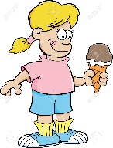
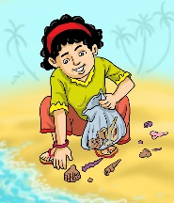
4

5
- She’s collecting s __ __ s __ e __ l __.

ANSWER KEY
EXERCISE 1
- Sun
- Sea
- Ice cream
- Beach
- Sand
- Boat

EXERCISE 2
- He’s swimming – 2
- She’s eating ice cream – 4
- They’re building a sandcastle – 1
- They’re going camping – 3
- She’s collecting seashells – 5

