Name: ____________________________ Surname: ____________________________ N^{ber}: ____ Grade/Class: _____
Assessment: _____________________________ | Date: ___________________________________________________
 | Teacher’s signature:  ___________________________ | Parent’s signature:  ___________________________

1) Unscramble the words and match.
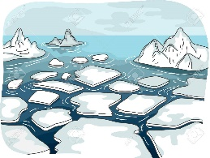

S o n w
a) _________________

I e c
b) _________________

S f o n l a w e k
c) _________________

S d l e g e
d) _________________

S m n o w a n
e) _________________

U b l l m r e a
f) _________________

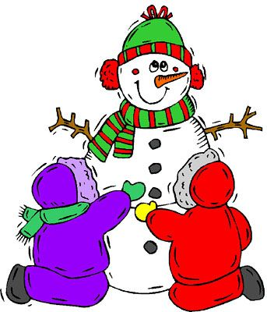
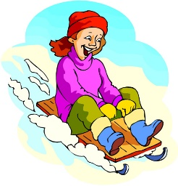
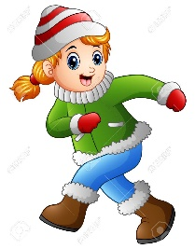
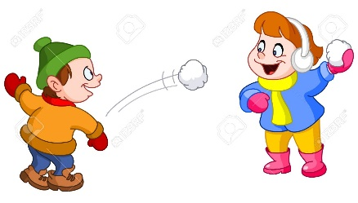
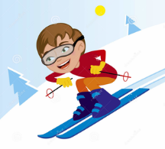
2) Match.
- Riding a sledge
- Throwing snowballs
- Making a snowman
- Running in the snow
- Drinking hot chocolate
- Skiing

ANSWER KEY
EXERCISE 1
- Snow
- Ice
- Snowflake
- Sledge
- Snowman
- Umbrella

EXERCISE 2
- Riding a sledge
- Throwing snowballs
- Making a snowman
- Running in the snow
- Drinking hot chocolate
- Skiing

4
2
5
6
3
1

