TOPIC: Seasons | SUBTOPICS: vocabulary related to autumn; weather | LEVEL: A1
Name: ____________________________ Surname: ____________________________ N^{ber}: ____ Grade/Class: _____

Autumn

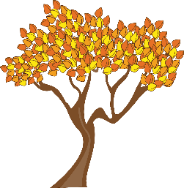
1) Read and match.

- T __ e __
- S q __ __ r __ __ l
- L __ __ v __ s
- M __ __ h __ o __m s
- C __ o __ d
- P __ m __ k __ n
- __ c __ r __ s
- C __ e __ t __ __ t s

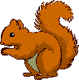

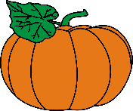

2) What‘s the weather like?
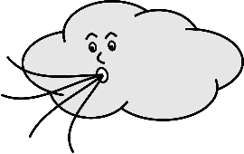
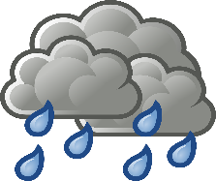

- It’s ____________ b) It’s ____________ c) It’s____________ b) It’s ____________

3) What‘s the weather like today?
Today, _________________________________________________.

