TOPIC: Seasons | SUBTOPICS: vocabulary related to spring; spring activities | LEVEL: A1
Name: ____________________________ Surname: ____________________________ N^{ber}: ____ Grade/Class: _____

Spring

1) Fill in the gaps.
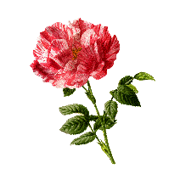
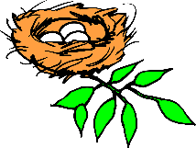
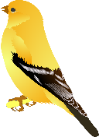

a) f __ __ __ __ __ | b) b __ __ __ | c) g __ __ __ __ | d) n __ __ __

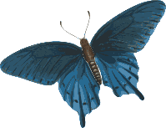
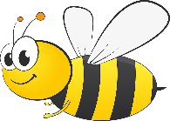
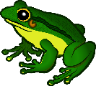

e) f __ __ __ | f) b __ __ __ __ __ __ __ __ | g) r__ __ __ __ __ __ | h) b __ __

2) Match.
- picking …

- doing…

- having…

- riding…

- catching…
… a bike

… butterflies

… the gardening

… a picnic

… flowers
