TOPIC: Seasons | SUBTOPICS: vocabulary related to spring; colours | LEVEL: A1
Name: ____________________________ Surname: ____________________________ N^{ber}: ____ Grade/Class: _____

Spring

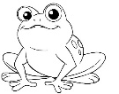
1) Write. Then colour.
- It’s a ____________ _____________.

- It’s a ____________ _____________.

- It’s a ____________ _____________.

- ______________________________.

- ______________________________.

- ______________________________.
green

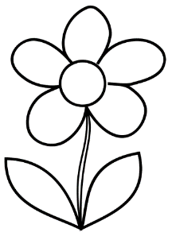
red

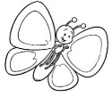
purple

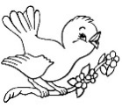
black

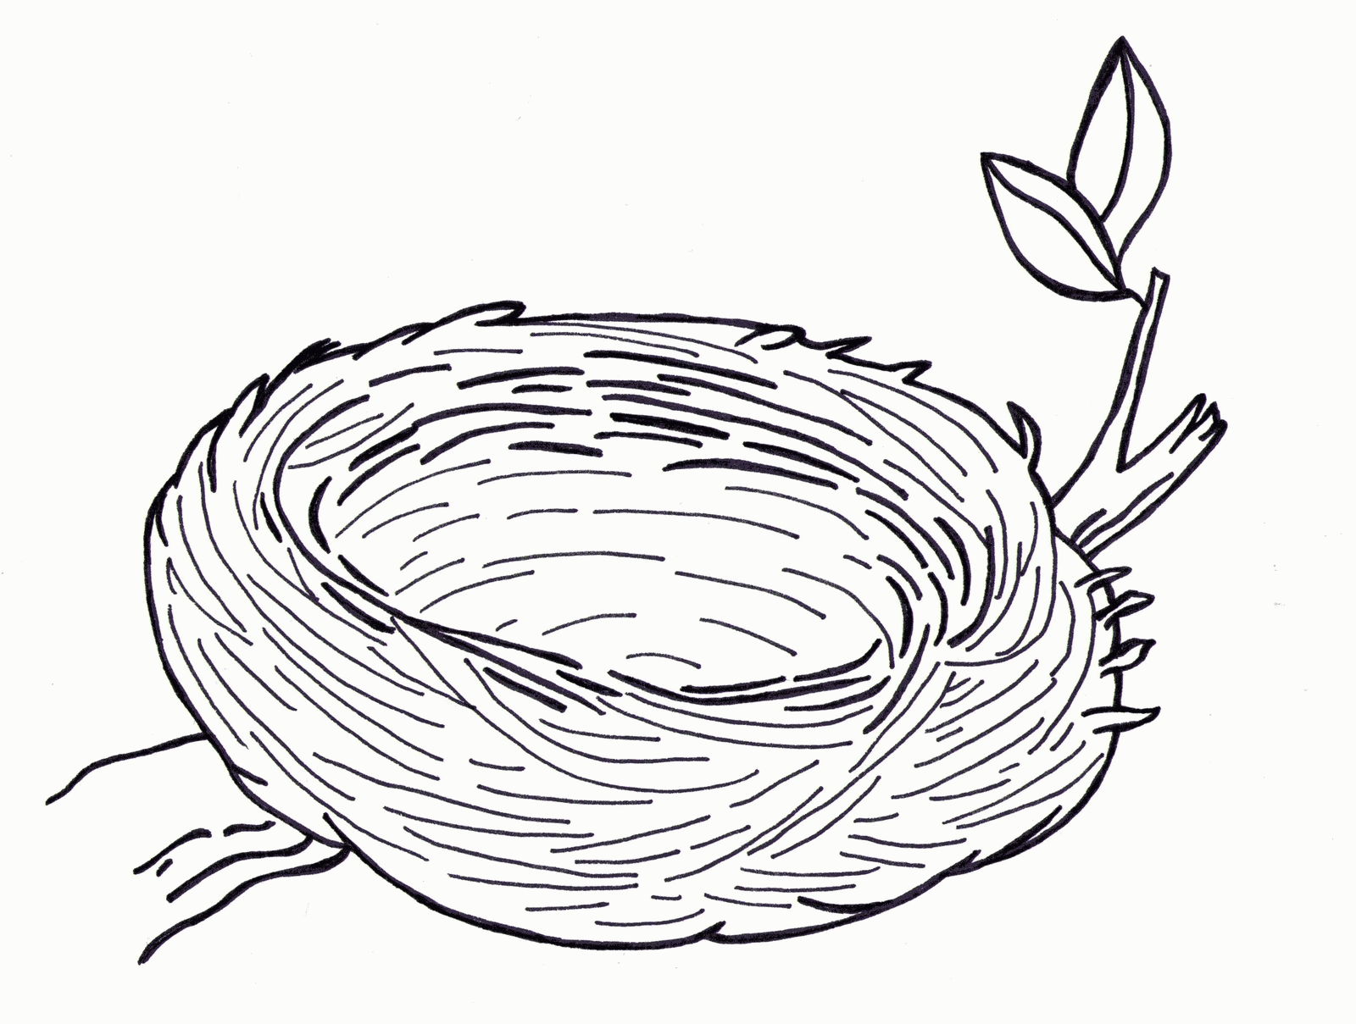
brown

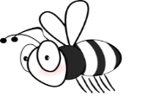
yellow

2) Read and choose the best answer. Put a tick

a) Spring is in…
- March. b) June. c) September.

b) In spring it’s…
- Snowy and very cold. b) sunny and very hot. c) sunny and warm.

c) In spring I love…
a) collecting acorns. b) picking flowers. c) riding a sledge.

