TOPIC: Seasons | SUBTOPICS: vocabulary related to winter; weather; winter activities | LEVEL: A1
Name: ____________________________ Surname: ____________________________ N^{ber}: ____ Grade/Class: _____

Winter

1) Unscramble the words and match.
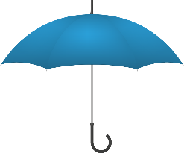
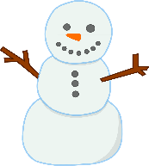
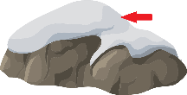
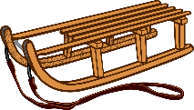

n w s o | s w e k f n o l a | c e i | s g e d l e | m e a r u b l l | s w a n m n o

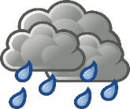
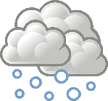
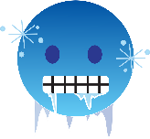
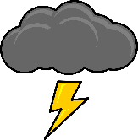
2) What‘s the weather like?

- It’s ____________ b) It’s ____________ c) It’s____________ b) It’s ____________

3) Match. Then write
… snowballs
… a snowman
… hot chocolate
… in the snow
… a sledge
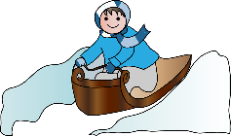
- Running…
- Riding…
- Throwing…
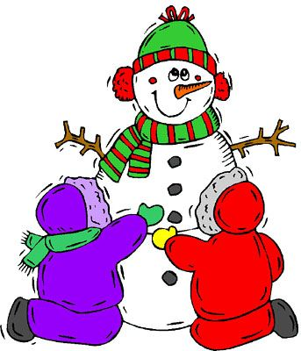
- Making…
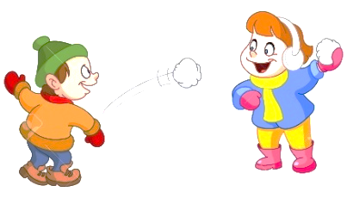
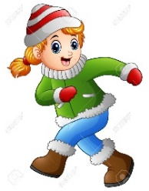
- Drinking…

