Name: ____________________________ Surname: ____________________________ N^{ber}: ____ Grade/Class: _____
Assessment: _____________________________ | Date: ___________________________________________________
 | Teacher’s signature:  ___________________________ | Parent’s signature:  ___________________________

Write about the activities you like, don’t like, love or hate, according to the season.
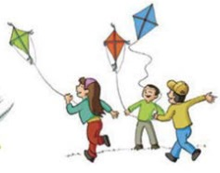
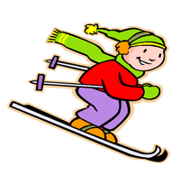
W_ _t _ r
A _ t _ _ n

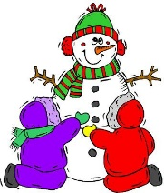

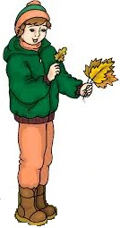
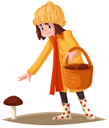
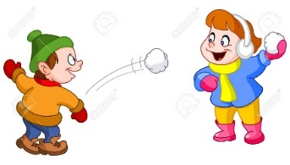
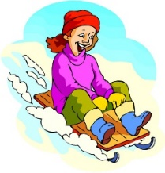
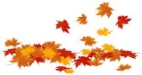
S_ m_ _r
S_ r_ _ g
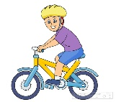
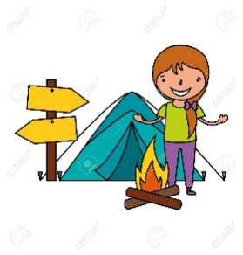

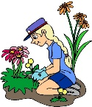
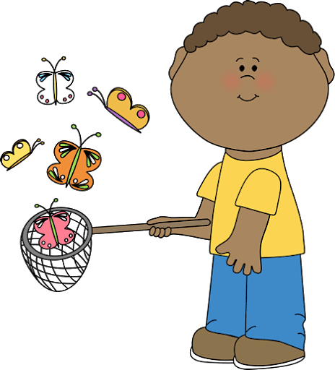

a) In a________________, I ____________ ______________________________________.
b) In w_______________, I ____________ ______________________________________.
c) In s________________, I ____________ ______________________________________.
d) In s________________, I ____________ ______________________________________.
ANSWER KEY

- In autumn I like… (e.g. eating chestnuts. / picking mushrooms.)
- In winter I don’t like… (e.g. skiing. / throwing snowballs.)
- In spring I love… (e.g. having a picnic. / riding a bike.)
- In summer I hate… (e.g. collecting seashells. / building sandcastles.)

