Name: ____________________________ Surname: ____________________________ N^{ber}: ____ Grade/Class: _____
Assessment: _____________________________ | Date: ___________________________________________________
 | Teacher’s signature:  ___________________________ | Parent’s signature:  ___________________________

- Look at the pictures and write.

…riding…
…having…
…doing…
… a picnic.
… the gardening.
… a bike.
…hate…
…like…
…love…

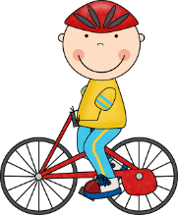

- I __________________________________________________.

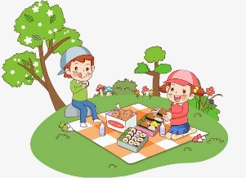
- I __________________________________________________.

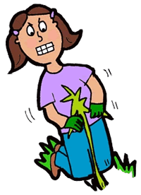
- I ___________________________________________________.

- Put the words in order.
- _________________________________.
- _________________________________.
- _________________________________.
- __________________________________.
- flowers / she / picking / is / .
- are / they / butterflies / catching / .
- season / my / is / favourite / spring / .
- yellow / this / is / bird / a / .

ANSWER KEY

1)
a) I like riding a bike.
b) I love having a picnic.
c) I hate gardening.

2)
a) She’s picking flowers.
b) They are catching butterflies.
c) My favourite season is spring.
d) This is a yellow bird.

