Name: ____________________________ Surname: ____________________________ N^{ber}: ____ Grade/Class: _____
Assessment: _____________________________  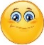  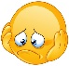  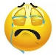 | Date: ___________________________________________________
 | Teacher’s signature:  ___________________________ | Parent’s signature:  ___________________________

- What are they doing? Look at the pictures and write.
I’m…
He’s…
They’re…
She’s…

…riding…
…throwing…
…running…
…drinking…
…snowballs.
…hot chocolate.
…in the snow.
…a sledge.

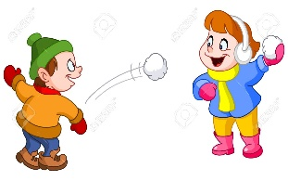
…..

- ____________________________________ c) ____________________________________
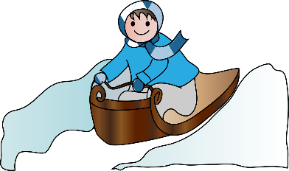
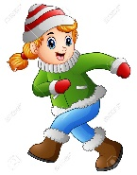

- ____________________________________ d) ____________________________________

- Look and write.
love * a snowman * hate * skiing * making
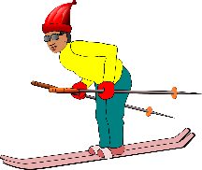

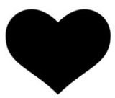
I ________________________________________________________.

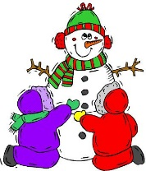
I ________________________________________________________.

ANSWER KEY

1)
a) I’m drinking hot chocolate.
b) She’ running in the snow.
c) They’re throwing snowballs.
d) He’s riding a sledge.

2)
a) I love skiing.
b) I hate making a snowman.

