TOPIC: Seasons | SUBTOPICS: autumn activities | LEVEL: A1
Name: ____________________________ Surname: ____________________________ N^{ber}: ____ Grade/Class: _____

Autumn Activites

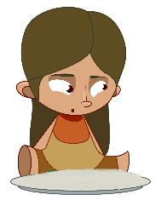
1) Match. Then write.

- She is __________________

- He is __________________

- They are _______________

- _______________________

- _______________________

- _______________________

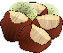
mushrooms

chestnuts

acorns

leaves

in a pile of leaves

a kite

Collecting

Jumping

Flying

Picking

Collecting

Eating

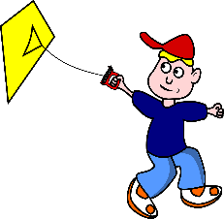

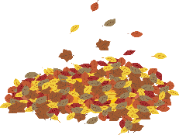

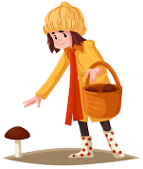

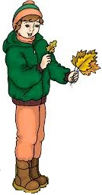

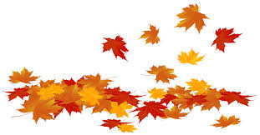

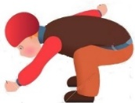
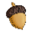
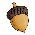

2) What’s your favourite autumn activity? Write and draw.

- My favourite autumn activity is _______________________________________.

