Name: ____________________________ Surname: ____________________________ N^{ber}: ____ Grade/Class: _____
Assessment: _____________________________ | Date: ___________________________________________________
 | Teacher’s signature:  ___________________________ | Parent’s signature:  ___________________________

- What are they doing? Look at the pictures and write.
…eating…
…flying…
…jumping…
…picking…
…in a pile of leaves.
…chestnuts.
…mushrooms.
…a kite.

I’m…
He’s…
They’re…
She’s…

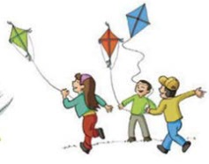
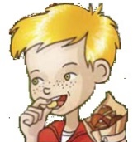
…..

- ____________________________________ c) ____________________________________
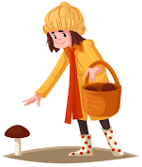
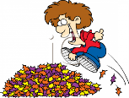

- ____________________________________ d) ____________________________________

- Put the words in order.
- I’ve _________________________________.
- There are ____________________________.
- I like ________________________________.
- It’s __________________________________.
- seventeen / I’ve / got / acorns / .
- leaves / five / There are / orange / .
- red / I like / leaves / collecting / .
- green / a / It’s / kite / .
ANSWER KEY

1)
- I’m eating chestnuts.
- He’s jumping in a pile of leaves.
- They’re flying a kite.
- She’s picking mushrooms.

2)
a) I’ve got seventeen acorns.
b) There are five orange leaves.
c) I like collecting red leaves.
d) It’s a green kite.

