TOPIC: Seasons | SUBTOPICS: winter activities; I like / I love / I hate | LEVEL: A1
Name: ____________________________ Surname: ____________________________ N^{ber}: ____ Grade/Class: _____

Winter activities

1) What are they doing? Complete.
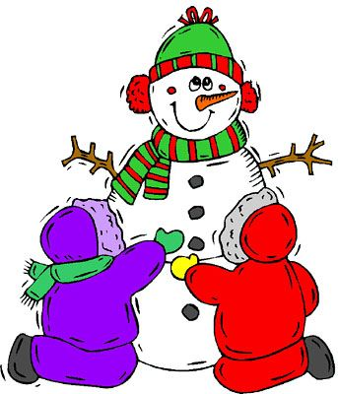
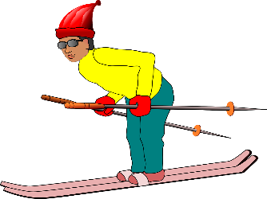

a) He is __ k __ __ n __ | b) They are m__k__ __g a s__ __w__ __ __
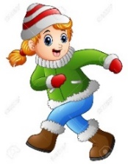
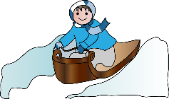

c) She is r__n__i__g in the __n__w | d) _____ _____ r__d__ __g a s__ __d__ __
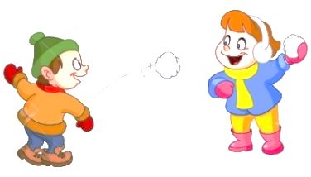

e) _____ ____ d__ __n__i__ g hot c__________ | f) ______ _____ t__r__w__ __g s____________

2) Write the winter activity you like, love and hate.
I ___________________________________________________.

I ___________________________________________________.

I ___________________________________________________.

